**UNIVERSITI TEKNOLOGI MARA**

**GAMIFIED MENTAL HEALTH SUPPORT MOBILE APPLICATION FOR UNIVERSITY STUDENTS**

**MUHAMMAD IDZWAN HAZIQ BIN MOHD ANUAR**

**BACHELOR OF COMPUTER SCIENCE (Hons.)**

**JULY 2025**

**Universiti Teknologi MARA**

**Gamified Mental Health Support Mobile Application for University Students**

**Muhammad Idzwan Haziq Bin Mohd Anuar**

**Thesis submitted in fulfilment of the requirements for Bachelor of Computer Science (Hons.) Faculty of Computer and Mathematical Sciences**

**JULY 2025**

**SUPERVISOR APPROVAL**

**GAMIFIED MENTAL HEALTH SUPPORT MOBILE APPLICATION FOR UNIVERSITY STUDENTS**

By

**MUHAMMAD IDZWAN HAZIQ BIN MOHD ANUAR**

**2024794671**

This thesis was prepared under the supervision of the project supervisor, Dr Khairulliza Binti Ahmad Salleh. It was submitted to the Faculty of Computer and Mathematical Sciences and was accepted in partial fulfilment of the requirements for the degree of Bachelor of Computer Science (Hons.).

Approved by

……………………………….

Dr Khairulliza Binti Ahmad Salleh

Project Supervisor

JANUARY

**STUDENT DECLARATION**

I certify that this thesis and the project to which it refers is the product of my own work and that any idea or quotation from the work of other people, published or otherwise are fully acknowledged in accordance with the standard referring practices of the discipline.

…………………………

MUHAMMAD IDZWAN HAZIQ BIN MOHD ANUAR

2024794671

JANUARY

**ACKNOWLEDGEMENT**

Alhamdulillah, all praises to Allah SWT for giving me the strength, patience, and ability to complete this Final Year Project successfully. This journey would not have been possible without His blessings and guidance. I would like to express my deepest gratitude to my supervisor, Dr Khairulliza BintI Ahmad Salleh, for their invaluable guidance, constructive feedback, and continuous support throughout the development of the Gamified Mental Health Support Mobile Application. Their mentorship played a crucial role in shaping the direction of this research and ensuring the project met its objectives. My sincere appreciation goes to the Faculty of Computer and Mathematical Sciences, Universiti Teknologi MARA (UiTM), for providing the necessary facilities and resources to conduct this study. I am also eternally grateful to my parents and family for their endless love, prayers, and financial support. Their encouragement kept me motivated during the challenging phases of system development and documentation. Finally, a special thanks to my friends and the 31 university students who volunteered to participate in the User Acceptance Test. Your honest feedback and willingness to test the application were instrumental in evaluating the success of this project. Thank you.

**ABSTRACT**

Mental health issues among university students have become a significant concern in recent years. Despite the availability of support resources, many students hesitate to seek help due to stigma or a lack of engagement with traditional self-help tools. Existing mobile applications often fail to sustain user interest over time which limits their effectiveness as long-term monitoring tools. To address this problem, this project presents the development of a Gamified Mental Health Support Mobile Application designed specifically for university students. The primary objective of this project was to develop a mobile application that integrates clinical assessment with gamification elements based on the Self-Determination Theory. The project utilized the Mobile Application Development Lifecycle (MADLC) methodology to ensure a structured development process. The application was built using the Flutter framework for the user interface and Firebase for backend services including real-time database management and authentication. Key features of the application include the DASS-21 clinical assessment for tracking stress, anxiety, and depression scores, a Daily Mood Check-in with a historical Moodboard, a Mental Health Knowledge Quiz, and a Journaling feature with image support. To evaluate the effectiveness of the application, a User Acceptance Test was conducted with 31 university students. The findings revealed that the application was highly well-received. The results indicated that 71.0% of users rated the ease of use as excellent, and 74.2% reported that the gamification elements such as leveling up and badges significantly increased their motivation to perform self-care activities. In conclusion, this project successfully demonstrates that integrating gamification into mental health tools is an effective strategy to enhance user engagement and provide students with an accessible platform for emotional well-being.

**TABLE OF CONTENTS**

**CONTENT PAGE**

**SUPERVISOR APPROVAL**  ii

**STUDENT DECLARATION** iii

**ACKNOWLEDGEMENT** iv

**ABSTRACT**  v

**TABLE OF CONTENTS** vi

**LIST OF FIGURES**  ix

**LIST OF TABLES** xi

**LIST OF ABBREVATIONS**  xii

**LIST OF APPENDICES** xiii

**CHAPTER ONE: INTRODUCTION** 1

1. Introduction 1
2. Background of Study 1
3. Problem Statement 2
4. Project Objective 4
5. Project Scope 4
6. Significance of Study 6
7. Conclusion 7

**CHAPTER TWO: LITERATURE REVIEW** 8

1. Introduction 8
2. Overview of Mental Health 10
   1. Common Mental Health Disorders 10
   2. University Students’ Mental Health Challenges12
3. Overview of Gamification 14
4. Gamification Framework 14
   1. Self-Determination Theory (SDT 15
   2. Mechanic, Dynamic, Aesthetic (MDA)

Framework 17

* 1. Octalysis Framework 19

1. Comparison of Existing Applications 21
   1. Happify 22
   2. eQuoo 23
   3. UABWell 24
2. Justification on Selected Gamification Framework

and Game Elements 25

1. Conclusion 27

**CHAPTER THREE: METHODOLOGY** 29

1. Introduction 29
2. Project Methodology 29
   * + 1. Phase 1: Identification Phase 30
       2. Phase 2: Design Phase 32
       3. Phase 3: Development Phase 33
       4. Phase 4: Prototyping Phase 35
       5. Phase 5: Testing Phase 36
       6. Phase 6: Deployment Phase 37
       7. Phase 7: Maintenance Phase 38
3. Summary of Project Methodology 38
4. System Architecture 40
5. Hardware and Software Requirement 42
   * + 1. Hardware Requirement 42
       2. Software Requirement 43
6. Conclusion 44

**CHAPTER FOUR: PROJECT DESIGN, IMPLEMENTATION AND RESULT** 46

1. Introduction 46
2. Project Design 46
3. Storyboard 47
4. Use Case Diagram 48
5. Flowchart 49
6. Entity-Relationship Diagram (ERD) 51
7. Project Development 53
   * + 1. Integration of Mental Health and Gamification 53
       2. Developing Gamified Mental Health Support

Mobile Application 54

1. Testing 74
2. User Feedback 76
   * + 1. Demographic Data 76
       2. Ease of Use 77
       3. Motivation and Gamification 78
       4. Overall Satisfaction and Qualitative Feedback 79
3. Conclusion 81

**CHAPTER FIVE: CONCLUSION AND RECOMMENDATION** 82

1. Introduction 82
2. Overall 82
3. Objective 83
   1. First Objective 83
   2. Second Objective 84
   3. Third Objective 84
4. Limitations 85
5. Recommendations 85
6. Conclusion 86

**REFERENCES** 88

**APPENDICES** 93

**LIST OF FIGURES**

**FIGURE PAGE**

2.1 Conceptual Map 9

2.2 Venn Diagram for SDT Framework 17

2.3 The perspective between designer and player 18

2.4 The design counterpart for MDA 18

2.5 The Octalysis Gamification Framework 20

2.6 Interface of the Happify 22

2.7 Interface of the eQuoo 23

2.8 Interface of the UABWell 24

3.1 Mobile Application Development Lifecycle 30

3.2 System Architecture of the Gamified Mental Health

Support Mobile Application for University Students 41

4.1 Storyboard of Gamified Mental Health Support Mobile

Application for University Students (Part 1) 47

4.2 Storyboard of Gamified Mental Health Support Mobile

Application for University Students (Part 2) 48

4.3 Use Case Diagram of Gamified Mental Health Support

Mobile Application for University Students 49

4.4 Flowchart of Gamified Mental Health Support Mobile

Application for University Students 50

4.5 Entity-Relationship Diagram of Gamified Mental Health

Support Mobile Application for University Students 52

4.6 Gamified Mental Health Support Mobile Application Logo 54

4.7 Login and Signup Screen of Gamified Mental Health Support

Mobile Application 55

4.8 Dashboard Screen of Gamified Mental Health Support

Mobile Application 60

4.9 Moodboard Screen of Gamified Mental Health Support

Mobile Application 61

4.10 DASS-21 Assessment Screen of Gamified Mental Health

Support Mobile Application 62

4.11 Knowledge Quiz Screen of Gamified Mental Health

Support Mobile Application 66

4.12 Journal Entry Screen of Gamified Mental Health Support

Mobile Application 68

4.13 Badge selection popup of Gamified Mental Health Support

Mobile Application 71

4.14 Profile Page and Avatar Selection of Gamified Mental Health

Support Mobile Application 72

4.15 Age Distribution 77

4.16 Gender Distribution 77

4.17 User feedback on ease of use 78

4.18 User feedback on motivation and gamification (Part 1) 79

4.19 User feedback on motivation and gamification (Part 2) 79

4.20 User feedback on overall satisfaction 80

4.21 Some of user suggestion for improvement 80

**LIST OF TABLES**

**TABLE PAGE**

2.1 Comparison Table of Gamification Framework 20

2.2 Comparison between similar applications 25

3.1 Identification Phase of MADLC 32

3.2 Design Phase of MADLC 33

3.3 Development Phase of MADLC 34

3.1 Prototyping Phase of MADLC 36

3.5 Testing Phase of MADLC 36

3.6 Summary of Project Methodology 39

3.7 Hardware Requirement 42

3.8 Software Requirement 44

4.1 Coding Snippets of Login Function for Gamified Mental Health

Support Mobile Application 56

4.2 Coding Snippets of Signup Function for Gamified Mental Health

Support Mobile Application 58

4.3 Coding Snippets of DASS-21 Calculation for Gamified Mental

Health Support Mobile Application 62

4.4 Coding Snippets of Knowledge Quiz for Gamified Mental Health

Support Mobile Application 66

4.5 Coding Snippets of Journal Function for Gamified Mental Health

Support Mobile Application 68

4.6 Coding Snippets of Gamification Logic for Gamified Mental

Health Support Mobile Application 72

4.7 Functionality Testing of Gamified Mental Health Support

Mobile Application 75

**LIST OF ABBREVIATIONS**

ADHD Attention Deficit Hyperactivity Disorder

mHealth Mobile Health

DASS-21 Depression Anxiety and Stress Scale 21

COVID-19 Coronavirus disease 2019

PHQ-9 Patient Health Questionnaire-9

BD Bipolar disorder

MDA Mechanics–Dynamics–Aesthetics

SDT Self-Determination Theory

MADLC Mobile Application Development Life Cycle

ERD Entity Relationship Diagram

UX User Experience

UI User Interface

UiTM Universiti Teknologi MARA

SDK Software Development Kit

IDE Integrated Development Environment

UAT User Acceptance Test

XP Experience Points

APK Android Package Kit

UID User Identifier

iOS iPhone Operating System

GIF Graphics Interchange Format

**LIST OF APPENDICES**

**APPENDIX PAGE**

A The DASS-21 Questionnaire 93

B The PHQ-9 Questionnaire 94

**CHAPTER 1**

**INTRODUCTION**

* 1. **Introduction**

This chapter introduces a proposed project on a gamified mobile application to support university students' mental health. The chapter begins with a brief explanation on the background of study – focusing on mental health, university students, and how gamification may assist in mental health support. The chapter then proceeds to address the problem statement and the project’s objectives. Next, the chapter also addresses the scope and significance of study by identifying the target demographic, the elements of gamification that was implemented in the mobile application and discussing the impact that this research have on university students' mental health. To conclude the chapter, a summary of the chapter’s important points is presented in the final section.

* 1. **Background of Study**

University students are increasingly vulnerable to mental health challenges, including stress, anxiety, depression, and burnout, due to academic pressures, social transitions, and financial concerns. According to study by Mason et al. (2025), after surveying 72,288 first-year university students across 18 countries, it was found that approximately two-thirds of first-year university students screened positive for at least one lifetime mental disorder, with the majority still meeting the criteria for these disorders during the year the survey was conducted. Student’s well-being is not the only thing that mental health effects, but it also has major consequences on their academic performance. For example, a study using Pakistan university students, found a strong relation between mental health problems and academic performance. The study found that students that have mental health issues, such as anxiety and depression, usually have lower academic achievements highlighting the importance of good mental health among university students (Zada et al., 2021). One potential help in supporting healthy mental health that has been researched by past researchers is the use of gamification elements within tools such as a mental health mobile application. For instance, research by Litvin et.al. (2023) found that their mental health mobile application that incorporates gamification elements causes a massive increase in resilience, reduction in depression and anxiety and notably lower attrition rate among students (Litvin et al., 2023).

The term gamification was coined by scholars as the usage of video game elements to give gamified experience to the end user (Cremaschi et al., 2025). The gamification elements have been used a lot in various fields such as education, entertainment and health. Gamification has proven to be a promising approach in the field of eHealth for enhancing well-being and addressing mental health challenges (Cremaschi et al., 2025). The same study also has explored the effectiveness of gamified therapy approaches, particularly in engaging youth and addressing psychological conditions such as Attention Deficit Hyperactivity Disorder (ADHD), autism spectrum disorders, anxiety, and dyslexia. These studies suggest that gamification is a great tool to help improve the mental health of university students. Therefore, this project aims to leverage insights from existing research to develop an engaging gamified mobile application that supports mental health and emotional well-being among university students.

* 1. **Problem Statement**

Ideally, mental health mobile applications that integrate interactive video game elements should be at the end of university students’ fingertips. Such tools have the potential to not only improve students' mental health but also help them maintain a stable and healthy emotional state over time. According to a study by Nicolaidou et al. (2022), mobile application using gamification elements was found to be effective in boosting user willingness to use it especially among younger and healthy groups of people. The same study also suggests that gamified mobile applications can be an effective tool for promoting good mental health, increasing end user motivation, and decreasing dropout rate among university students.

Mental health issue among university students is a major concern especially in Malaysia. According to a study by Mohamad et al. (2021) it was found that 29% of Malaysian university students are at risk of anxiety. This is due to academic pressure, financial support during study and difficulties in social circles. These challenges not only impacted students emotionally but are also the contributing factors for decreasing academic performance, leading to an increase in dropout rate. Based on the study conduct by Sinval et al. (2025), it was found that bad mental health, for example depression, anxiety and stress, have major consequences on student academic engagement and dropout intention. Thus, effective mental health support tools are urgently needed to address these growing concerns.

Unfortunately, the current state of mental health support does not fully align with this ideal scenario. Although some of the gamified mobile applications for mental health do exist, it mostly generates only short-term engagement, primarily driven by external rewards rather than sustained intrinsic motivation (Aydınlıyurt et al., 2021). The success of health management through mobile health (mHealth) applications largely depends on consistent user engagement. However, brief or infrequent use rarely leads to meaningful health outcomes. Studies indicate that sustained usage remains a significant challenge, with most users interacting with the app only four times, and around 25% discontinuing use after just a single session post-installation (Wang et al., 2021). Another similar study also found that 53% of mHealth application are uninstalled within 30 days, with abandonment mainly driven by declining motivation, regular application switching before choosing on a preferred option, lack of desired features, lack of engagement, and poor usability (Mustafa et al., 2022).

Based on the problems that have been identified above, there is a need for alternative ways to promote mental health to university students. Thus, this study proposes a development of a gamified mental health support mobile application for university students. This mobile application can help students to improve their mental health, and the gamification elements integrated within the mobile application may improve the engagement with the application. The gamification elements are also expected to enhance users’ intrinsic motivation to engage with the app by “simulating feelings of autonomy, competence, and connection with others” (Wang et al., 2021).

* 1. **Project Objective**

The proposed project is driven by three primary objectives that shape its overall development. These objectives are outlined as follows:

1. To identify gamification design framework that is effective in promoting mental health among university students
2. To develop a gamified mobile application that supports mental health wellbeing among university students
3. To evaluate the usability of the developed Gamified Mental Health Support Mobile Application for University Students
   1. **Project Scope**

The gamified mental health support mobile application incorporates several important features and objectives that aim to provide an innovative and effective tool for university students. First, the application was developed for university students around the age of 18 to 27, while factoring their cognitive development, academic pressures and digital preferences. This age group was chosen because university student is prone to mental health challenges making them the target age group of this project. According to study by Sivertsen et al. (2023) it was revealed that 39.7% of female and 25.7% of male Norwegian university students were identified with a current mental disorder. This application also provides a user-friendly interface, modern design elements and content relevant to university students to ensure continuous engagement. Second, the application integrates core gamification elements such as interactive challenges, point based rewards, experience bar and badges. These elements aim to enhance user motivation and emotional resilience. End users can earn badges and unlock achievements by completing mental health exercises and wellness check-ins.

Third, the application aims to cultivate psychological and emotional abilities essential for mental health, a key focus of modern healthcare. These core competencies, including self-awareness, emotional control, resilience building, social interaction, and decision-making, are strengthened by a strategic point system that rewards students for activities like mood tracking and journaling. This approach enhances motivation and provides an engaging way for students to build skills that promote overall well-being. Additionally, this project also draws on benefits of gamification that outlined by Cremaschi et al. (2025) such as enhancing motivation and emotional engagement. The application also includes a questionnaire for the students to answer. The Depression, Anxiety and Stress Scale (DASS - 21) is a 21-item questionnaire aimed at assessing current mental health and emotional conditions, identifying Depression, Anxiety, or Stress. Other than that, the application includes the option for journaling. Finally, the application was developed using Flutter and is optimized for a wide range of devices that is commonly used by university students. This ensures smooth user experience and accessibility across most devices. This allows end users to access the application at any time and integrate it as a part of their daily lives.

* 1. **Significance of Study**

Through the proposed solution, the significance of this project is on various fronts. Primarily, it introduces an innovative and engaging method for university students to manage and support their mental health using gamification. This makes the mobile application more interactive and motivating. Using prior research, especially on the effect of gamification on emotional and psychological state of university students by Nicolaidou et al. (2022), this project aims to create a mobile application that provide meaningful and informed experience to its user. The project objective aligns with the growth of mental health that are important for university students to manage their academic, social and personal challenges. These include stress and anxiety. By focusing on these critical areas, the application aims to contribute to the wellbeing of university students, helping not only their academic performance but also their ability to handle pressure.

Moreover, the application was accessible and enjoyable to address the ever-growing concern over mental health issues among university students. Today, many students often face the difficulties of engaging consistently in tackling mental health problems. This project provides an application where students can reflect, track their mental wellness, and practice the activities that can help improve their mental health. Additionally, the application can serve as supplementary tools for counsellors to help students better understand their emotions. Features like progress tracking, anonymous journaling and reward system helps students to have better understanding of mental health in technologically friendly and supportive ways. Hence, the proposed gamified mental health mobile application not only helps students to better understand about mental health but also contributes to broader culture of good mental health and wellbeing within university.

* 1. **Conclusion**

In conclusion, this chapter outlined the project's main goal which is to develop a gamified mobile application that effectively supports the promotion of mental health among university students. This chapter also explained the importance of mental health on university students and explained how gamification can aid their learning and practicing emotional and psychological skills. This chapter also highlighted the lack of engagement in these kinds of applications among university students and declared its main objectives. The project scope by detailing the key features and its development boundary were also presented. The project's significance lies in providing an engaging and accessible tool for promoting good mental health and emotional resilience among university students. By using gamification, this project was designed to support students in managing stress anxiety and other mental health challenges. Overall, this chapter lays the foundation for creating an interactive and impactful application to help promote mental wellbeing of university students and provides the roadmap for other parts of this research.

**CHAPTER 2**

**LITERATURE REVIEW**

**2.1 Introduction**

This chapter provides a comprehensive background on the planned development of a gamified mental health support mobile application for university students. It explores the importance and the impact of mental health disorder, and discusses the challenges faced by university students in Malaysia. This chapter also explores gamification and its frameworks and highlights how these gamifications elements can help university students to be more engaged with mental health support mobile application. This chapter concludes by emphasizing the gaps in current solution, the potential of fusing gamification with mental health support to increase engagement, promote good mental health and gives an accessible form of mental health support to the university students. Figure 2.1 illustrates the Conceptual Map of the projects.

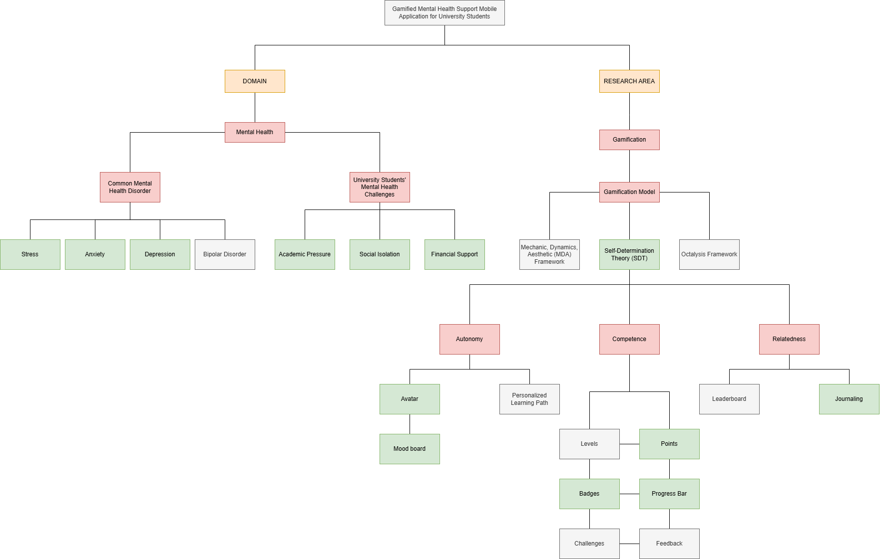

**Figure 2.1** Conceptual Map

**2.2 Overview of Mental Health**

Mental health is described as a person’s psychological well-being and ability to cope with life stresses. So, every person needs to maintain good mental health to function in life properly. This is especially true for university students. Good mental health promotes productivity and positive social contribution, but poor mental health worsens academic and personal success (Arifin et al., 2023). University is a stressful place for students. In the United States of America, a study found that roughly about 75% of college students are reported to have the feeling of stress (Barbayannis et al., 2022). Mental health issues not only affect American university students but also affects Malaysian adults. According to a study by Arifin et al. (2023), it was found that the percentage of adults in Malaysia who suffer from mental health issues has risen from 8.9% in 2012 to 10.7% in 2015 and to 31.1% in 2019. The findings also show that Malaysian students accounted for the bulk of reported cases. There are several mental health disorders among university students, but the common ones are stress, anxiety, depression and bipolar disorder.

**2.2.1 Common Mental Health Disorders**

Stress is one of the common mental disorders seen in university students. Stress is a natural and common human response to challenges and demands. There is a moderate amount of stress that is normal but an overflowing level of stress can negatively impact the students’ well-being. Studies from Malaysian researchers found that stress is prevalent among university student in Malaysia (Ahmad Fuad et al., 2024; Wong et al., 2023). According to a study conducted during COVID-19 pandemic in Selangor by Wong et al. (2023) it was found that 44.6% of university students experienced moderate to severe stress. This study uses the Depression Anxiety Stress Scale (DASS-21) as a method to assess stress. This 21-question questionnaire assess stress by focusing on symptoms related to persistent arousal and tension. The DASS-21 questionnaire is shown in the Appendix A. If stress levels are not managed effectively, they can significantly impact a student's academic achievement and self-quality, and failure to detect and address stress can lead to increased psychological morbidity (Ahmad Fuad et al., 2024).

Anxiety is another common mental health disorder seen in university students. Anxiety is a mental illness that has the potential to majorly impact a person’s life (Das et al., 2023). It is a natural body response to feelings of worry, fear and stress about things about to come and when the feeling is intense, tenacious and excessive, it can lead to anxiety disorder (Mohamad et al., 2021). Anxiety is a rising concern among university students. According to a study by Mohamad et al. (2021), after surveying 1860 students, it was found that 29% of university students surveyed in the study are at risk of anxiety. Another study conducted by Wong et al. (2023), using the DASS-21 questionnaire to survey the Selangor university students, found that 66.2% of students experienced moderate to severe levels of anxiety. Anxiety can have major impact on students’ life potentially affecting their academic performance, their well- being and also can increase the risk of suicide (Mohamad et al., 2021).

Depression is also one of the common mental health problems seen in university students. Depression is a psychiatric disorder that can majorly affect people's lives. It affects an individual’s feelings, thoughts and actions causing a variety of emotional and physical issues and can decrease the functionality of a person’s (Syeema Zulkafli et al., 2022). The rate of depression is higher among university students compared to the general population. According to a study from Syeema Zulkafli et al. (2022), using Patient Health Questionnaire (PHQ-9) to surveyed university students in Borneo, it was found that 82% of students is showing the symptoms of depression with 46% showing mild symptoms, 30% showing moderate, 17.9% shows moderate-severe and 6.1% severe symptoms. The PHQ-9 questionnaire is shown in the Appendix B. Another study from Wong et al. (2023), using DASS-21, found that 53.9% respondent is reported to have moderate to extremely severe depression. Depression can have a major impact on student life from lowers the academic performance and overall health to one of factors of suicidal behaviors.

Bipolar disorder (BD) is a disturbance in mood characterized by persistent, abnormally expansive, irritable, and elated mood with increased energy and goal-directed activity, decreased sleep, talkativeness, distractibility, and risky behavior, with three or more of these symptoms present for at least one week (Bete et al., 2024). Its prevalence among university students is not as big as stress, anxiety and depression. According to a study from Amin et al. (2024), BD is reported to affect 3.2% of college students in the Klang Valley.  BD is recognized to be a severe, chronic mental illness with a high morbidity and mortality, and has been designated as a public issue. BD has a severe effect on one's mood, mental status, personal hygiene, and interpersonal relationships (Ahmad Fuad et al., 2024). Due to the higher prevalence and impact of stress, anxiety and depression among university students as focused by DASS-21, this project focus on these three mental health challenges.

**2.2.2 University Students’ Mental Health Challenges**

Academic pressure is identified as one that play a major role in contributing to mental health challenges among university students. The transition from secondary school to university exposes students to a variety of challenging environments that includes increased academic pressure. This requires students to adjust to their new lifestyle, learning behavior and increase independence. An increased academic pressure is found to influence students’ mental health (Ahmad Fuad et al., 2024). Many factors may lead to academic pressure include having too many chapters to cover before quizzes, tests or examinations, challenging assignments and learning new subjects that they are not interested in. Competition between students for academic achievement can also contribute to academic pressure. A study suggests that students in the early terms of university face difficulty adjusting to their new academic life independently, and another study suggest that students’ mental health decreases later in academic years because of an increase of tougher workload (Mohamad et al., 2021; Syeema Zulkafli et al., 2022).

Social isolation and the lack of social connections are major factors impacting mental health. A lack of reliable community and social connection can cause loneliness, sadness, boredom, anxiety and even depression (Samsudin et al., 2024). Strong social support from family, friends, educators, community and social organization is considered a protective factor, which shields individuals from bad mental health. Friends offer empathy, companionship, and social interaction, which aids in alleviating feelings of loneliness and depression, while frequent social engagement enhances mental well-being (Amin et al., 2024). Being separated from families can cause missing loved ones and lose a space to discuss issues for university students. This can lead to moderate or maybe severe case of bad mental health.

Financial support another factor that can contribute to mental health issues. Financial factors including household income and financial instability are a major player when it comes to mental health problems in university students. Individuals that are well-off are less likely to show the symptoms of bad mental health compared to the individuals that are not so well-off (Samsudin et al., 2024). The increasing cost of higher education can also lead to higher pressure on students. This problem is prevalent in students that have financial constraints, which prevent some of them from continuing their studies. Furthermore, those who receives consistent financial support has lower risk of mental health problems than the students that had not received any (Mohamad et al., 2021).

In summary, university students face several mental health challenges including academic pressure, social isolation and financial support. All of these difficulties can impact their psychological well-being negatively. If left unattended, these challenges can lead to mental health problem such as, depression, anxiety and stress. Consequently, there is a demand for mental health support that are effective to help student maintaining a good mental health. One of the ways is by using mobile applications that offer psychological support. Incorporating features of gamification in such applications can offer a boost in user motivation and participation. This makes a link between students' psychological problems and making a support application based on gamification, which is the basis of the research area now.

**2.3 Overview of Gamification**

Gamification refers to a practice of adding game like design elements in a non-game field to motivate and engage the end user. The gamification elements include points, badges, challenges and avatars. These techniques originally popularized in business and education fields but lately gamification has spread to variety of fields including health care and well-being (Cheng & Ebrahimi, 2023). In mental health fields, gamified applications are used to increase user engagement and promote positive behaviors. There are many mental health applications that already have incorporated gamification elements into their therapy exercise. Elements like points, rewards, badges and challenges are some of the examples that has been integrated into these mental health applications (Cheng & Ebrahimi, 2023). These elements have shown to improve the applications usage and its outcomes. According to a study from Wang et al. (2021), it was reported that mental health applications that use gamification have increases user resilience and reduce mental health problems more than the normal applications. The gamified elements motivate users to continue self-care tasks.

**2.4 Gamification Framework**

Gamification frameworks are structured approaches that help implement game elements on non-game activities while ensuring that design is purposeful and aligned with motivation for users. These frameworks also guide developers on choosing game mechanics and understanding user behavior. Popular gamification frameworks that are widely used such as the MDA Model (Mechanics-Dynamics-Aesthetics) and the Octalysis Framework oversee gamification to engage users through their psychological needs and behavior triggers. Specifically, Self-Determination Theory (SDT) offers a theoretical framework for gamification contexts to understand intrinsic motivation as fulfilling autonomy, competence, and relatedness. The incorporation of SDT in gamification design enables developers to design more substantial and motivational user experiences by linking game features with users' basic psychological needs.

**2.4.1 Self-Determination Theory (SDT)**

Self-Determination Theory or SDT, is a main psychological framework for gamification, focusing on autonomy, competence and relatedness as key human needs. In the gamification context, fulfilling these needs encourages intrinsic motivation. According to a study by Wang et al. (2021), by using SDT on a mobile health application, it was found that gamification elements intended for raising the feeling of autonomy, competence and relatedness each majorly predicted intrinsic motivation and continuous application usage. Another study done by Castellano-Tejedor & Cencerrado (2024), found that gameful designs need to include purposeful choices, skill-based challenges and the opportunities for social connection. This all focuses on satisfying SDT needs and changing users’ motivation from extrinsic to intrinsic. In educational and clinical interventions, fulfilling SDT requirements has been linked to better engagement. Serious game builds for patient education can boost intrinsic motivation by providing competence-building challenges, allowing autonomy via decision-making, and promoting relatedness through social interaction (Naor & Dubovi, 2025).

SDT proposes three basic psychological needs, which are autonomy, competence and relatedness, that support intrinsic motivation (Litvin et al., 2020). Autonomy is the need to feel conscious and in control of one’s actions. Gamification elements assist autonomy by allowing users to make meaningful choices and personalization. For example, avatar customization and flexible goal selection enable students to showcase their identity and practice self-direction (Wanniarachchi et al., 2025). Private activities like mood board and personalized learning path also empower students to reflect on their own feelings on their own terms. As SDT-base design framework highlights, giving meaningful choices and personalization satisfies autonomy by letting users choose their own learning and health management (Castellano-Tejedor & Cencerrado, 2024).

Competence is the desire to feel proficient and capable. Gamified application fulfils this by providing explicit challenges, feedback and visual progress indicator. Elements like point systems, badges, levels, and progress bars clearly display achievement and signal mastery (Wang et al., 2021). Feedback and gradually increasing challenges strengthen self-efficacy and intrinsic motivation (Brownlow, 2022; Castellano-Tejedor & Cencerrado, 2024). In practice, creating missions at an appropriate difficulty level guarantees that students often achieve success, thereby enhancing their sense of competence.

Relatedness is the need to feel connected and supported by others. Gamified mental health applications address relatedness via social features that connect students with peers or mentors (Brownlow, 2022; Wang et al., 2021). As an example, elements like leaderboard, team challenges or social feeds enable students to share their progress and encourage each other. This feature can give rise to community building. A study from Nicolaidou et al. (2022) found that allowing users to post their achievements on a community board, for example, "I completed my exercise goal," reduced feelings of isolation and motivated the individual through social criticism. Furthermore, optional peer comments or group discussion can be added to journalling or mood-tracking features. These changes can turn private reflection into mutual support. Empirical reviews emphasize that online communities and peer interaction in health applications fulfil relatedness needs and support ongoing commitment in behavior change (Brownlow, 2022). Finally, a student-focused gamified design clearly includes elements like customization, feedback and social sharing that align with SDT principles of autonomy, competence and relatedness, thus boosting motivation and engagement. Figure 2.2 shows a Venn diagram on SDT Framework.

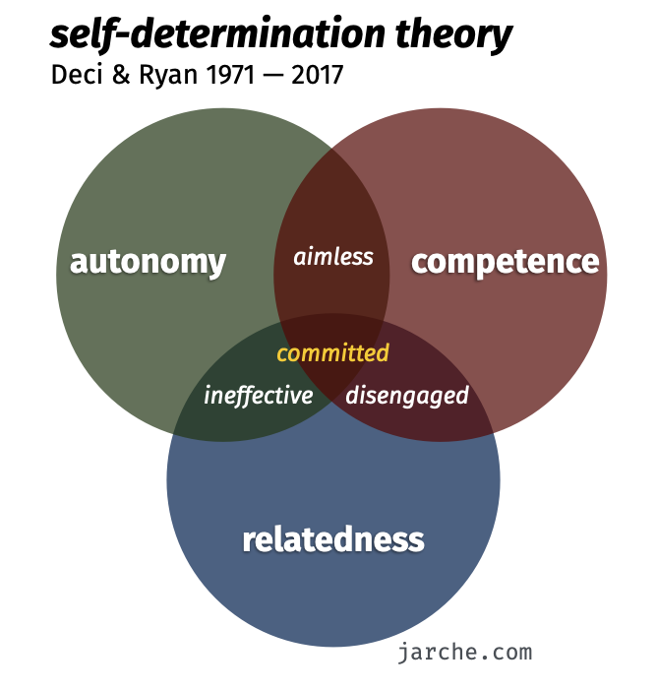

**Figure 2.2** Venn Diagram for SDT Framework (Source: Jarche, 2014)

**2.4.2 Mechanic, Dynamic, Aesthetic (MDA) Framework**

Mechanic, Dynamic, Aesthetic (MDA) framework originally developed by Hunicke et al. (2004), break down gameful design into three layers. These layers are mechanics, which is the rule and element of the game such as points or progress indicator, dynamics, defined by the behavior during system operation and feedback loops, and aesthetics, which is the emotional responses like enjoyment or difficulty that emerge (Junior & Silva, 2021). MDA serves as a design tool to aid developers in making sure that fundamental mechanics generate captivating dynamics and positive emotional reactions. In mental health application fields, elements like badges, level or daily challenges can foster dynamics such as competition, collaboration or personal challenges. These elements consequently create positive aesthetic experiences like a feeling of success, flow or social bonding. According to a study from Pérez-Jorge et al. (2024) found that MDA based games produce a significant improvement in adolescent motivation, mental health and satisfaction. Another study by Rubio & Olmedilla (2021) found that when using MDA as a design guideline, their gamified intervention for low-intensity psychological training that includes clear goals, feedback loops and social elements is capable of enhancing motivation and minimizing dropout rate. These studies imply that MDA based applications would carefully incorporate its mechanics, game elements, with dynamic gameplay flow and aesthetics, positive user experiences, to ensure that reward systems and social challenges affect the behavior positively. Figure 2.3 shows the perspective between designer and player and Figure 2.4 shows the design counterpart for MDA.

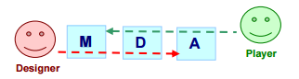

**Figure 2.3** The perspective between designer and player

(Source: Hunicke et al., 2004)

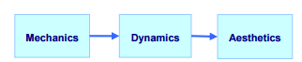

**Figure 2.4** The design counterpart for MDA (Source: Hunicke et al., 2004)

**2.4.3 Octalysis Framework**

The Octalysis model developed by Chou (2016) offers a comprehensive gamification heuristic based on eight core drives of motivation. These drives are Epic Meaning, Development or Accomplishment, Empowerment or Creativity, Social Influence, Unpredictability, Scarcity, Ownership and Avoidance. Each of these drives can be influenced by different gamification elements. As an example, social influence drive can be influenced by introducing elements like leaderboard, team challenges or peer support. Another example is development or accomplishment drive can be leveraged by clear progress feedback and goals. Epic meaning can be caused by narrative or cause-related rewards. A bibliometric analysis from Mohanty & Christopher B (2023) notes that Octalysis has become one of the well-known convincing tools for altering user behavior by strategically following this framework to fulfil these drives. In implementation, designers could align app functionalities with particular Octalysis drives. For instance, providing students with virtual incentives for achieving self-care objectives, which fulfil accomplishment drive, facilitating user-generated content or creative introspection which fulfil empowerment drive, or demonstrating tangible effects in the real world which fulfil epic meaning drive. Although Octalysis enjoys greater popularity in industry and educational gamification compared to its presence in published mental-health trials, it illustrates the potential of combining various motivational levers. For a mental-health application aimed at students, Octalysis recommends enhancing SDT and MDA insights by directly focusing on drives like social connectedness and feeling of progress. A study from Mohanty & Christopher B (2023) found that eight drives of Octalysis can motivate a wide range of engagement strategies, though studies on its application in health contexts are still developing. Figure 2.5 shows the Octalysis Gamification Framework.

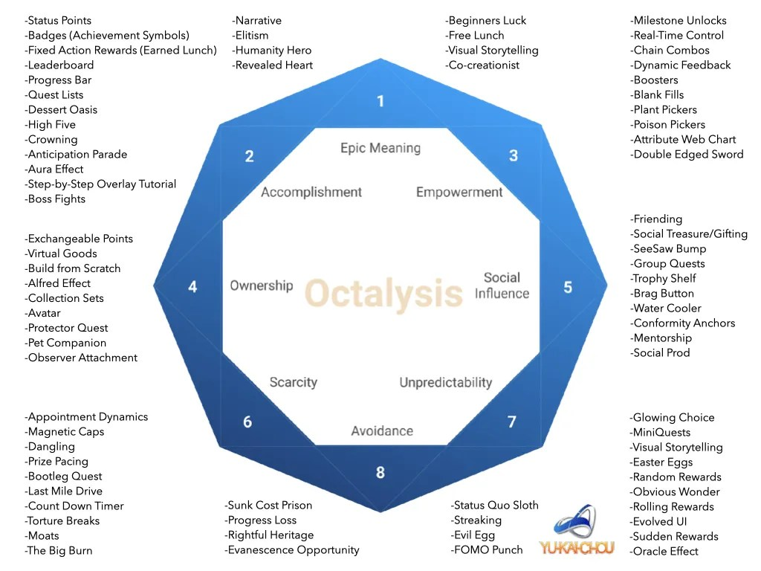

**Figure 2.5** The Octalysis Gamification Framework (Source: Chou, 2016)

**Table 2.1** Comparison Table of Gamification Framework

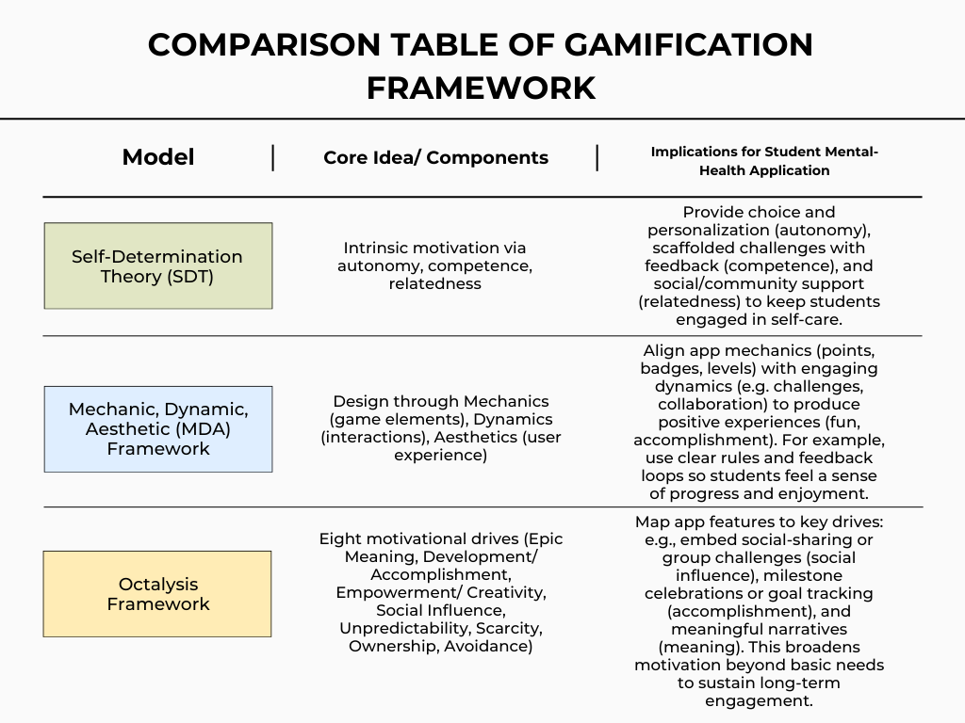

The table 2.1 above shows the comparison between three of most popular gamification frameworks, SDT, MDA and Octalysis framework. Based on the comparison above and the intended features of the proposed mental health support application, Self-Determination Theory (SDT) has been identified as the most appropriate gamification design model to be adopted in this study. SDT emphasizes three base psychological needs, autonomy, competence, and relatedness, required in fostering intrinsic motivation and sustaining healthy behavior change. These dimensions are direct support for university students' mental health in terms of enhancing self-awareness, emotional regulation, and social interaction. While frameworks such as the MDA Model and Octalysis Framework provide structural and motivational perspectives, SDT is more psychologically rooted in the creation of interventions to address the underlying causes of mental illness. Therefore, in fulfillment of the first research objective, which is to identify a gamification design framework that is effective in promoting mental health among university students, SDT is selected for its strong theoretical alignment with the goals and psychological outcomes targeted by the planned application.

**2.5 Comparison of Existing Applications**

This section discusses an extensive review and discussion of existing mobile applications with comparable functional and conceptual aspects to the proposed project. The applications are critical controls for measuring the impact of gamified design interventions and online interaction tools in enhancing mental health and emotional well-being, particularly among university students and young adults. Among the many app that had been created using this concept, the notable one selected for analysis are Happify, eQuoo, and UABWell. These applications were developed to promote psychological resilience, reducing symptoms of bad mental health and to increase user engagement using interactive and gamification features. By exploring their design characteristics, engagement mechanisms, and documented effectiveness, this comparison provides valuable insights into best practices and potential areas for enhancement in future mental health app development. Based on this comparison, the proposed application aims to fill the gap by combining the clinical validity of DASS-21 with the engagement of gamification, which many existing apps lack.

**2.5.1 Happify**

Happify is a mental well-being application based on science offering self- directed exercises rooted in positive psychology. The gamification elements that exist in the application, such as points, medals, streaks and progress bars, are used to increase user engagement and motivation. Happify is targeted at teens and adults. This application also offers a broad range of interactive exercises created to boost mental health. Research, such as a randomized controlled trial in adolescents, has delivered significant stress and emotional well-being improvement. Some content is only accessible with a subscription, and users may become tired of the content through repeated use. Happify's overall ease of access and evidence-based practice make it well-suited to a high population, although its gamification is quite low in comparison to more interactive applications (Boucher et al., 2021).

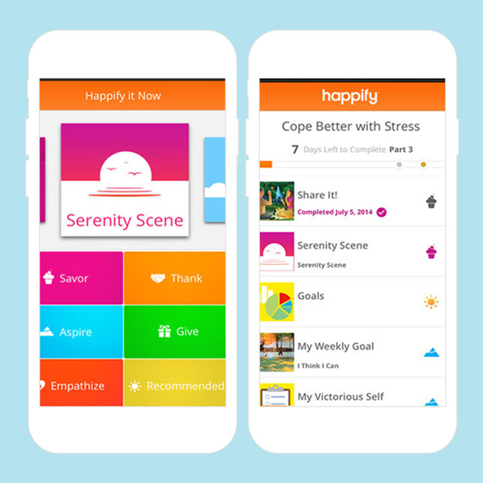

**Figure 2.6** Interface of the Happify (Sources: Lee, 2021)

**2.5.2 eQuoo**

eQuoo is an emotional fitness application for university and young adult populations that uses interactive storytelling, weekly chapters, and roleplay-based choice making to transfer psychological skills associated with resilience. A large-scale randomized controlled trial of eQuoo demonstrated large improvements in resilience and reductions in anxiety and depression when compared to an active control and waitlist. This application strong narrative framework and weekly progression system lead to increase in user engagement. While its story-based format is highly engaging, the one chapter every week format may lower the user satisfaction. eQuoo’s strengths lie in its effective gamification and proven outcomes, though it is less adaptable for users outside the student demographic (Litvin et al., 2023).

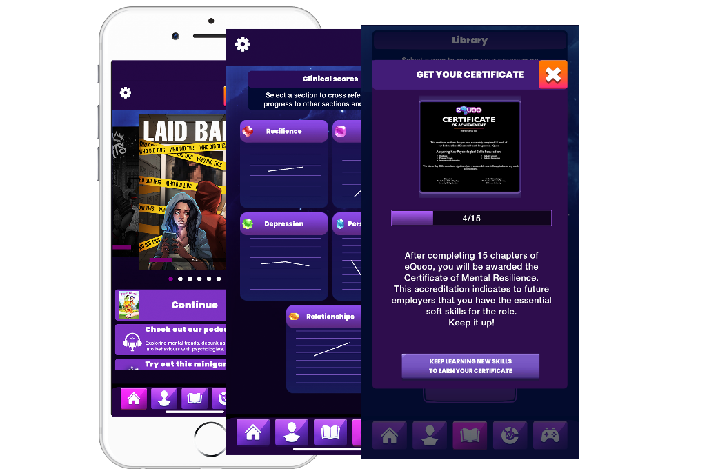

**Figure 2.7** Interface of the eQuoo (Source: EQuoo for Students - PsycApps, 2025)

**2.5.3 UABWell**

UABWel is a mobile application created specifically for University of Alabama at Birmingham students. This application focuses are on habit tracking, personalized wellness plans, and campus resources integration rather than gamified, structured play. It's made with ease and routine building in mind and has very little gamification in the form of streaks and checklists. While student-oriented, it has not been officially tested in clinical settings and is not available for the general public. Future revisions will further amplify gamification. The power of UABWell is campus-specific usability and individualized goals, but its limited audience and initial version status constrain broader application (Herfurth, 2025).

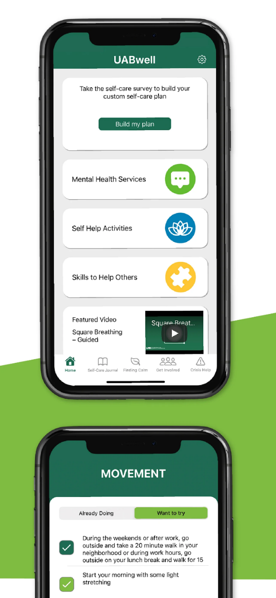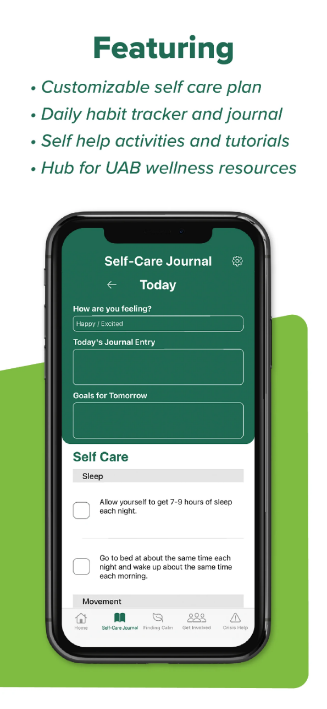

**Figure 2.8** Interface of the UABWell (Source: UABwell - Apps on Google Play, 2023)

Table 2.2 below presents a comparison between three existing mental health support applications and the proposed application, Emoticore.

**Table 2.2** Comparison between similar applications

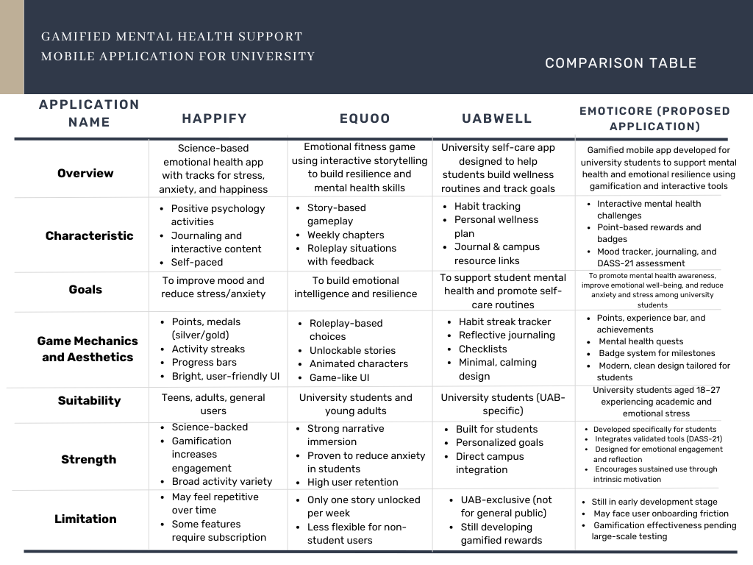

**2.6** **Justification on Selected Gamification Framework and Game Elements**

Self-Determination Theory (SDT) has been identified as the most appropriate gamification framework for this study due to its strong psychological foundation and proven effectiveness in motivating long-term behavior change. SDT emphasizes the fulfillment of three core psychological needs, which includes autonomy, competence, and relatedness, as essential drivers of intrinsic motivation (Litvin et al., 2020; Wang et al., 2021). These needs are especially pertinent for university students who frequently encounter academic pressure, social seclusion, and emotional exhaustion.

In accordance with SDT, this project’s gamification framework includes targeted game elements for each psychological requirement to enhance involvement and emotional health. These mechanics were chosen for their ability to fulfill the intrinsic motivations of the user group and are outlined below.

Autonomy pertains to the individual's desire to feel in charge of their decisions and behaviors. To enhance autonomy, the app offers avatar personalization and a custom mood board. These elements enable students to convey their identity and customize their experiences based on their preferences. According to Wanniarachchi et al. (2025), avatar customization fosters a sense of ownership and personal relevance, which can improve user engagement. Similarly, mood boards empower users to reflect on and track their emotions privately, reinforcing self-awareness and independent emotional regulation (Castellano-Tejedor & Cencerrado, 2024). By giving users, the freedom to choose how they present themselves and explore their mental state, these elements fulfill the autonomy dimension of SDT. Additionally, some avatar cosmetics are unlocked through the point system, offering users new options to personalize their virtual identity as they progress through the app.

Competence is the need to be competent and effective in order to achieve goals. The application uses a point system, a progress bar, and achievement badges to satisfy this need. Users earn points for completing various self-care activities, and their accumulation is visualized by a progress bar. As shown in previous studies, visual progress indicators and achievement systems enhance perceived competence and self-efficacy (Brownlow, 2022; Wang et al., 2021). After accumulating a certain number of points and filling the progress bar, users unlock achievement badges and other rewards. Additionally, integrating feedback into journaling allows users to receive validation and encouragement, which reinforces a sense of mastery and motivates continued participation.

Relatedness is the psychological need to feel a sense of belonging, understanding, and support from others. In this project, reflective journaling is then mostly used as the gamified mechanic to address relatedness. While in general journaling is an individual activity, as it has the intentional questions and structured reflection embedded in it, users can process emotions and recognize similarities and establish an internal sense of connection and empathy. As Brownlow (2022) noted, even self-reflection would enhance perceived relatedness when users are asked to think about their social relationships, emotional connections, and values. Integration of reflection prompts such as "Who assisted you during the week?" or "What made you feel connected today?" within the journal feature might foster both social awareness and emotional connectedness. Although social networking is not overt within the app, this inward-oriented mechanism of relatedness aligns with SDT theory in how it makes users feel psychologically connected with others although not necessarily interacting directly (Naor & Dubovi, 2025).

In conclusion, the use of SDT is not only theoretically founded but practically implemented through carefully cultivated game mechanics that speak directly to autonomy, competence, and relatedness. As opposed to extrinsically motivated designs based on surface-level engagement, like leaderboards, an SDT-oriented approach drives more emotional investment, supports self-regulation, and promotes long-term adherence to positive habits (Naor & Dubovi, 2025). Therefore, SDT provides an integrated and comprehensive evidence-based theory for the development of a gamified mental health app following the psychological needs of university students.

**2.7 Conclusion**

This chapter provides a comprehensive review of literature that was relevant to the development of this project, stressing on mental health especially on common disorders such as stress, anxiety and depression, particularly among the Malaysian university students. Then, this chapter focused on the university students’ mental health challenges that include academic pressure, social isolation and financial support. Next, this chapter introduces gamification and its framework used in mental health fields. This framework is Self-Determination Theory (SDT), the Mechanics–Dynamics–Aesthetics (MDA) framework, and the Octalysis Framework. This framework is compared with each other and the result is SDT is the suitable framework for this project. This chapter also reviewed recent mental health applications, which are Happify, eQuoo and UABWell, to identify the applications strengths and limitations. These applications provide valuable information on gamification in mental health applications and its effect on students’ retention and mental health. The SDT framework was utilized in the proposed development of a gamified mental health application targeted at university students with the purpose of enhancing motivation, reinforcing self-care, and making an accessible and fun support network available for improving mental health.

**CHAPTER 3**

**METHODOLOGY**

**3.1 Introduction**

This chapter presents the methodology of the project, which entails explaining the steps taken and the methods used to achieve the goals of this project. Additionally, this section provides the system architecture of the project, detailing the components, their interactions, and framework crucial for the project's operation. Ultimately, the chapter delineates the hardware and software requirements essential for the project's implementation.

**3.2 Project Methodology**

The methodology chosen for building the proposed Gamified Mental Health Support Mobile Application for University Students is the Mobile Application Development Life Cycle (MADLC), a systematic, repeated approach that details the stages necessary for developing and sustaining a mobile application. The planning, development, testing, deployment, and maintenance of an application are all guided by the systematic process known as the mobile application development lifecycle. With this method, developers may effectively finish each step while saving money and time, resulting in applications of superior quality (Ramesh, 2024). Figure 3.1 shows the phases of the Mobile Application Development Lifecycle.

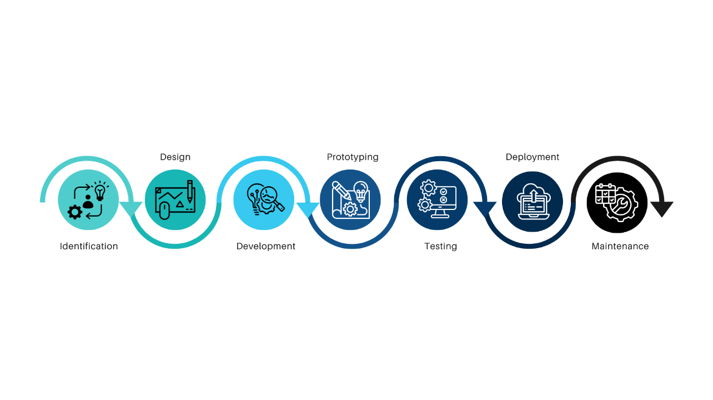

**Figure 3.1** Mobile Application Development Lifecycle (Vithani & Kumar, 2014)

The methodology consists of seven critical phases. These phases are Identification, Design, Development, Prototyping, Testing, Deployment and Maintenance (Vithani & Kumar, 2014). Through these established phases, the development of this project is ensured to be organized and systematic, resulting in functional and maintainable mobile application. This methodology not only streamlined the development process but also deepen the understanding of this project’s scope and objectives. This method is essential for creating good mental health application and helps the project to fulfil the objective stated in the previous chapter. This also help the application to provide a guide to good mental health behavior among the university students.

**3.2.1 Phase 1: Identification Phase**

Identification is the initial phase that focuses on developing new ideas or upgrading the existing ideas by compiling the ideas from the peers. The idea can be suggested by both the developers and end user of the product. Brainstorming is an important aspect when making new and innovative project (Roslan & Haron, 2024). Before proceeding to the next phase, the ideas need to be analysed completely for figuring out the scope and functionality of the application.

The initialization of the making of Gamified Mobile Health Support for University Students consisted of three important part which are the introduction, the literature review and the selection of methodology. The introduction chapter discussed the problem statement and the scope of this project which is to improve the mental health of the university students through gamification. Introduction is also the chapter where the project objectives were determined, and the potential outcome of this project were discussed.

The next chapter is on literature review. This chapter covers the project’s theoretical and empirical foundation. This was achieved by analysing the previous research done in the area – through literatures that are related to mental health domain and gamification area. This chapter also compared the existing applications released by prior developer to find research gaps and opportunities. This helps on highlighting the importance of the project idea.

As for the methodology chapter, it involves identifying the most suitable and effective methodology for the mobile application development process by analysing and appraising multiple methodology and its compatibility with the project outcomes and objectives. This helps the Gamified Mobile Health Support for University Students to be develop systematically. This also ensured a structured method on developing this project. Table 3.1 present the identification phase and the activities that had been completed for this project.

**Table 3.1** Identification Phase of MADLC

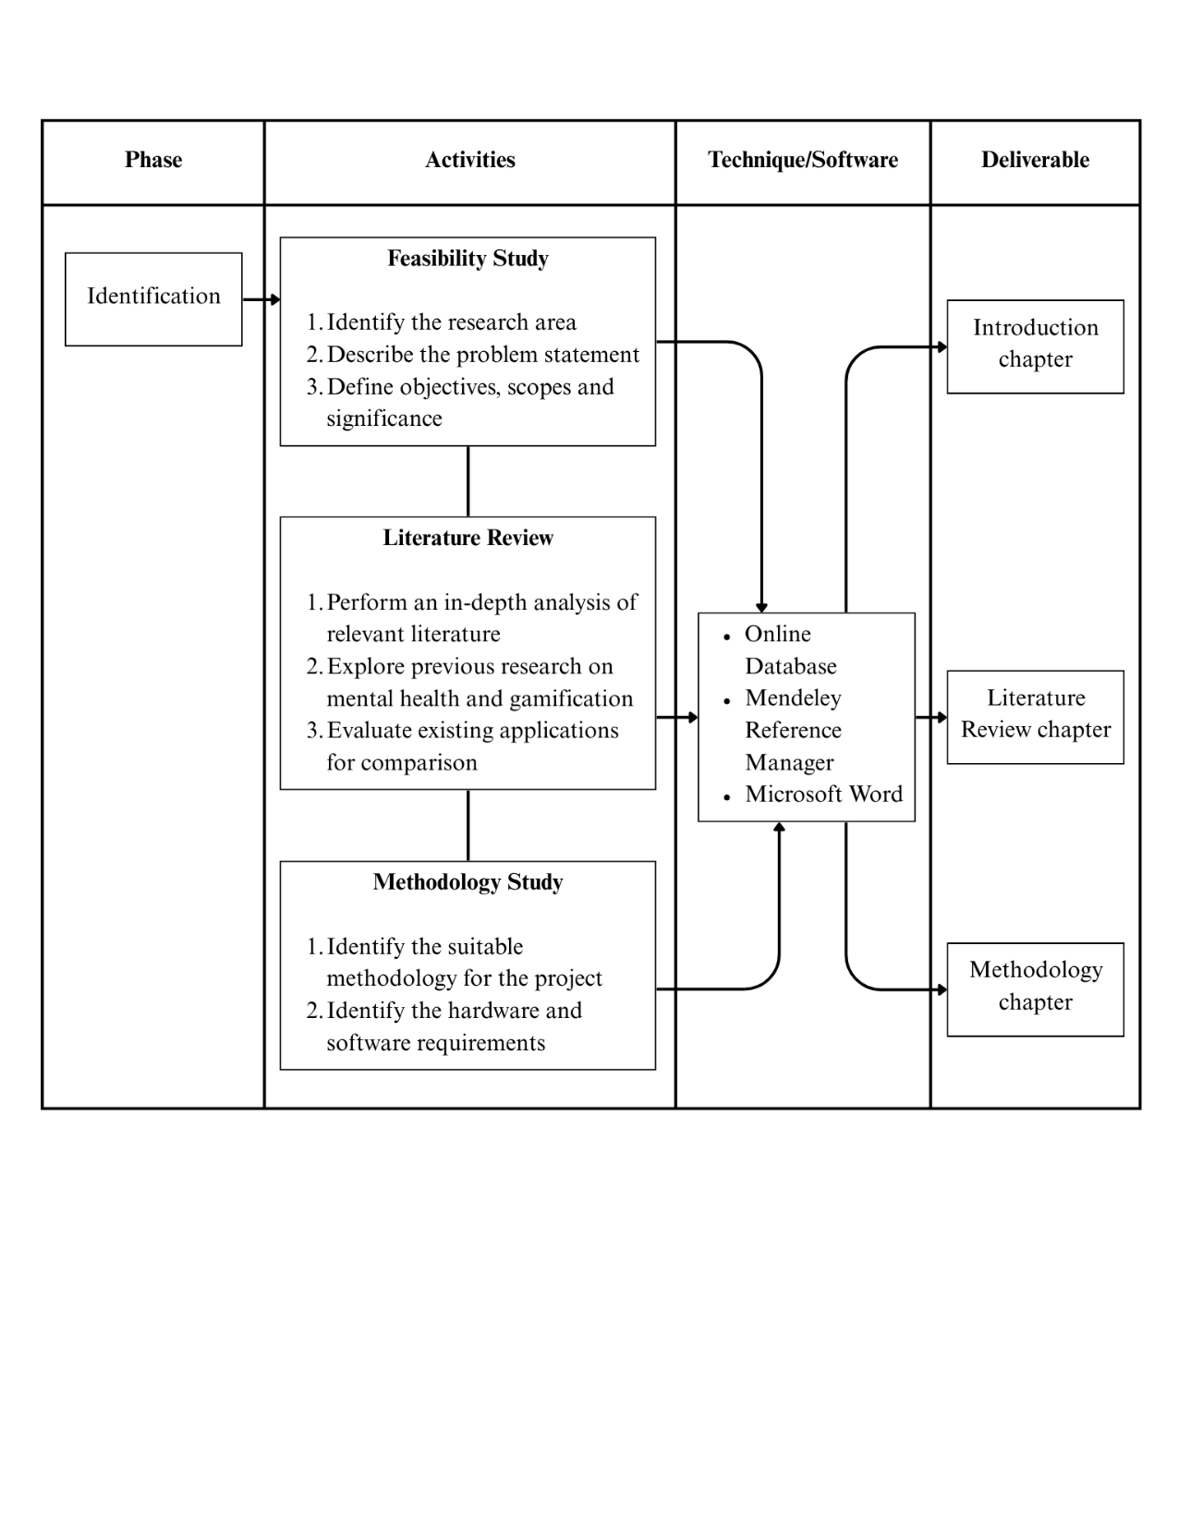

**3.2.2 Phase 2: Design Phase**

The second phase of MADLC which is design phase was a pivotal stage on developing a mobile application. Design phase entails transitioning the idea that had been brainstormed in the previous phase into an early design of the product (Roslan & Haron, 2024). This phase plays a crucial role in shaping the project overall architecture, user experience (UX) and user interface (UI). The design phase also entailed on producing a visual depiction of the mobile application appearance, performance and interaction. This phase comprised of designing a storyboard that demonstrate the UI. The application flow is also mapped in this phase to plan and visualize the UX (Vithani & Kumar, 2014). All of the design and description was included in chapter 4. Table 3.2 present the design phase of the project along with the activities that was executed.

**Table 3.2** Design Phase of MADLC

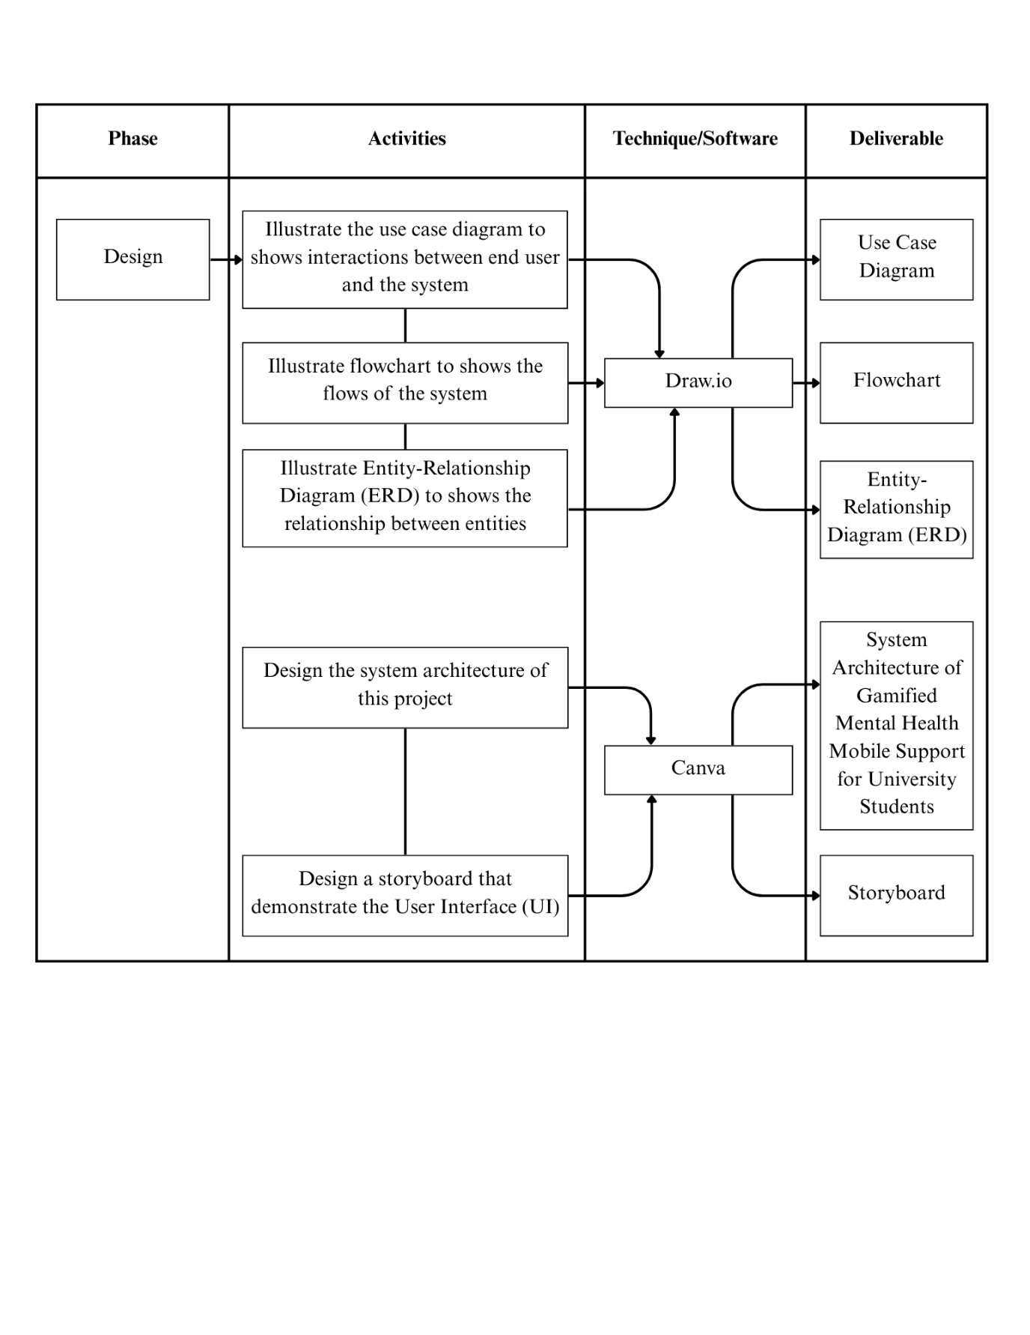

**3.2.3 Phase 3: Development Phase**

During this third phase of MADLC, the interface that has been designed was combined using programming language. The development phase of MADLC, the functional requirement and user interface (UI) was coded using suitable programming language (Wambua Wambua & Kamau Ndungu, 2023). This phase comprises the development of both the front-end and the back-end of the application. This guarantee that the development of the application is both visually attractive and provide a good user experience (UX). Table 3.3 present the process of the development phase of the MADLC.

**Table 3.3** Development Phase of MADLC

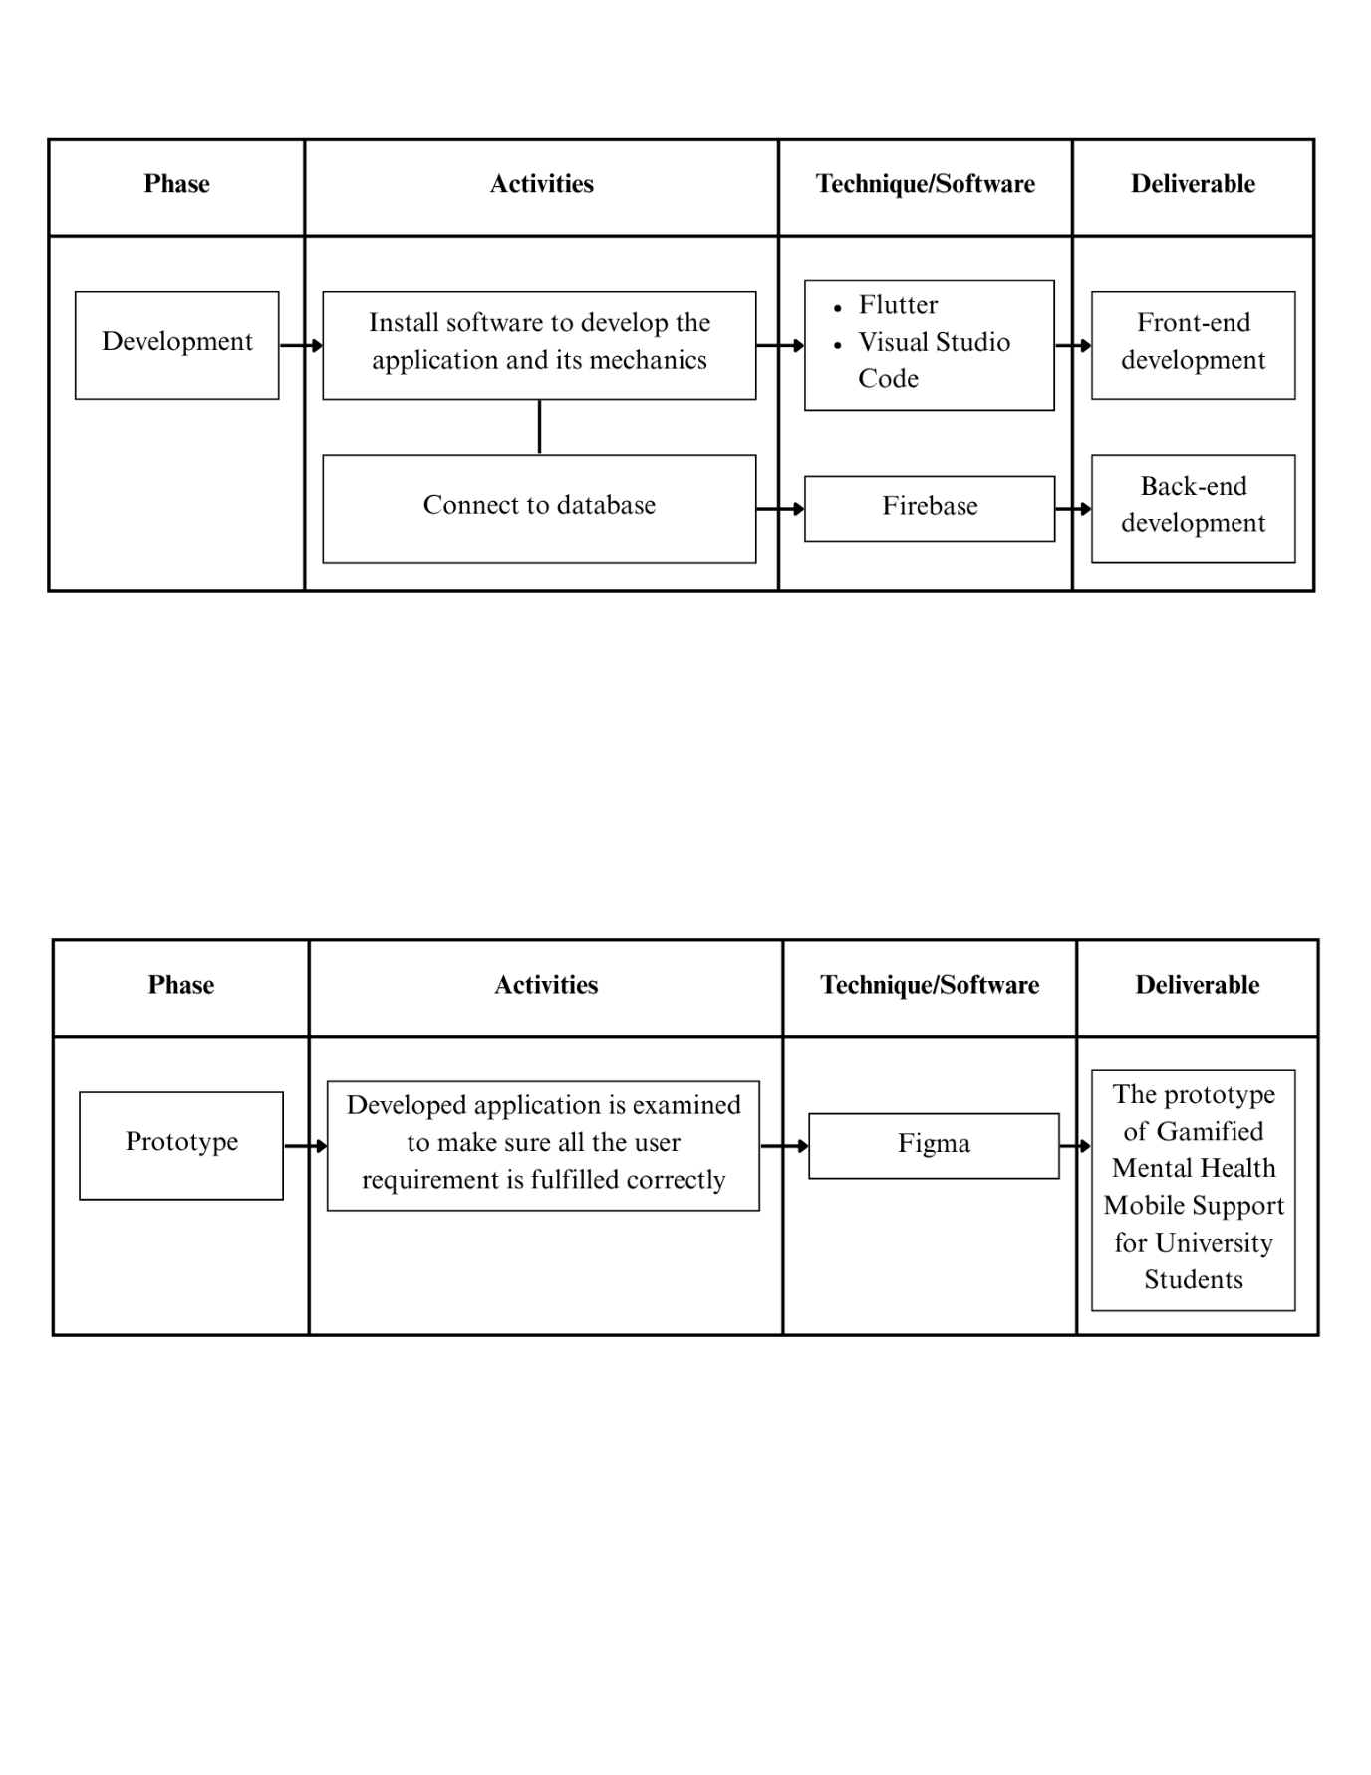

The development of the front-end for this project use Flutter and Visual Studio Code was the main tool to implement the UI. Flutter is a cross-platform framework that uses the single codebase to support the development of native-like applications. Wide range of customizable widgets and built in tools is provided by Flutter to ensure the responsive and interactive mobile applications can be developed. The programming language used by Flutter is Dart. Robust object-oriented structure offered by Dart streamlined the development of smooth navigation, animation and component styling. Both tools, Flutter and Visual Studio Code, provides an efficient and streamlined development environment for building the application’s interface and user experience.

The development of the back-end for this project utilizes Firebase to handle user authentication, data storage and operations with real-time database. Firebase is a cloud-based platform that offers scalable backend service that is suitable for mobile applications. The integration of Firebase and Flutter allow effortless interaction between UI and database. Firebase offers important feature like Firestore which enable the mobile application to store and receive user data efficiently. The data like mood logs, journal entries and quiz results can be stored and retrieve by the mobile application easily. The real-time capacity of Firebase guaranteed that updates were immediately reflected within the application. This ensured the fast and smooth user experience while using the application. The usage of Firebase within this project eliminates the need of using complex server-side configuration while maintaining secure data handling.

**3.2.4 Phase 4: Prototyping Phase**

In this fourth phase of MADLC, the developed application was examined to make sure all the user requirement is fulfilled correctly. According to Wambua Wambua & Kamau Ndungu (2023), during prototyping phase, the application usually is given to the client and feedback from client is collected. The feedback was integrated in the application and this step continue until all the functional requirements are fulfilled. Since this project did not involve a real-world client, feedback was obtained from UiTM Perak Branch, Tapah campus students, who represent the target user base. All of the functional requirements of this application were tested using Figma. These prototypes represented the project design, functionality and UI. The prototype was examined and given to potential end users. The data and feedback collected during this phase then be forwarded to the next phase which is the testing phase. The prototype tested by the potential end users allows early identification of usability issue, visual inconsistencies and navigation problems. This repeating process help the development of the application achieve a better quality and user-friendly mental Gamified Mental Health Mobile Support for University Students that fulfil both project requirements and end users need. Table 3.4 present the process of prototyping phase of this project.

**Table 3.4** Prototyping Phase of MADLC



**3.2.5 Phase 5: Testing Phase**

The fifth phase of MADLC, testing phase, is critical in mobile application development to ensure the usability and functionality of the application is running as smoothly as possible. The application will be tested thoroughly first using an emulator that are often included in Software Development Kits (SDK). It is important to test the developed application using various device with varying operating system version and screen size to ensure the end user get the optimal experience when using the application (Roslan & Haron, 2024). Table 3.5 presents the process of testing phase of this Gamified Mental Health Support Mobile Application for University Students.

**Table 3.5** Testing Phase of MADLC

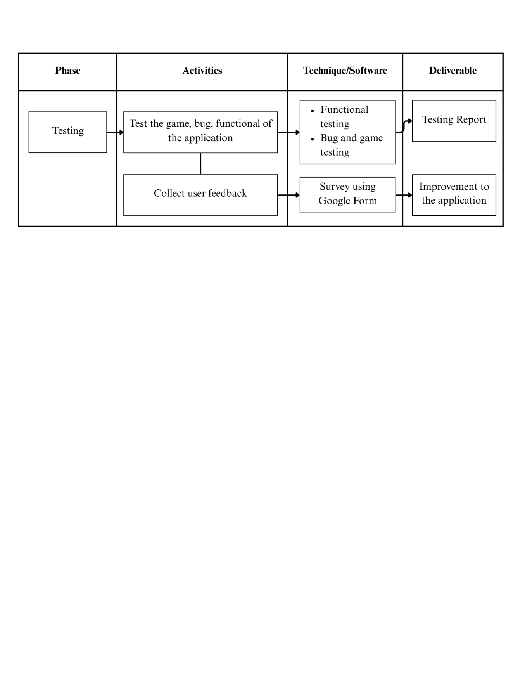

This phase employs a blended approach to usability testing. First, functional and game testing was administered to find and solve any application-related problems such as crashes, bugs, or glitches. This systematic process ensures the application is functioning correctly and meets all the requirements according to the project objectives. The testing was meticulously inspected by the developer to ensure the application's performance is evaluated completely.

In addition, remote, unmoderated usability testing with a survey was used to collect essential user feedback for refining the application. This systematic approach allows for the collection of detailed insights regarding user preferences, interface usability, and suggestions for improvement. The survey utilizes Google Forms with university students as the respondents, representing the main users of the application. Some participants from UiTM Perak Branch, Tapah campus, was chosen to assist in testing the prototype and offering their feedback based on their engagement with core features like mood tracking, journaling, and various gamified features. This process aid in confirming that the Gamified Mental Health Support Mobile Application has achieved its objective and provides an engaging user experience designed for students' needs.

**3.2.6 Phase 6: Deployment Phase**

The deployment phase is the sixth phase of MADLC and the final stage of the development for a mobile application. The application will be ready for release to the public after the testing was completed, and the last feedback was resolved. The deployment process consisted of submitting the finished application to appropriate app store and making it public so the end user can download and use the developed application. But it is worth noting that the deployment phase of MADLC is not applicable for this project. The application was developed for a final-year bachelor’s degree program and not intended for commercial release on platform such as Google Play Store or Apple App Store.

**3.2.7 Phase 7: Maintenance Phase**

The final phase of MADLC which is the maintenance phase focuses on ensuring the application’s quality and usability by gathering and resolving end user feedback. The feedback will be gathered through different methods, including surveys, comments and bug report, and then analysed to determine the strength and weaknesses of the application, as wells as to gauge the user satisfaction and engagement with the application. Based on the analysis result, the potential updates, enhancement and modification to the application could be planned to fulfil the end user needs and expectations. To clarify, the maintenance phase of MADLC is also not relevant for this project. The application was developed for a final-year bachelor’s degree program and not intended for commercial release so, the typical ongoing maintenance phase not be implemented.

**3.3 Summary of Project Methodology**

Table 3.6 summarizes the project methodology for the proposed development of the Gamified Mental Health Support Mobile Application for University Students. An organized overview on how each project objective was met throughout the various phases of the methodology were presented in the table. The links between objectives, activities, deliverables, phases and outcomes were outlined to ensure a structured understanding of the project’s progression.

This structured methodology provided a comprehensive and organized approach to fulfilling the established goals of the Gamified Mental Health Support Mobile Application for University Students. The methodology offered a well-defined framework that guided the overall execution of the project by clearly linking each objective with the corresponding phases, activities, and deliverables. Table 3.6 provide the summary of the project methodology.

**Table 3.6** Summary of Project Methodology

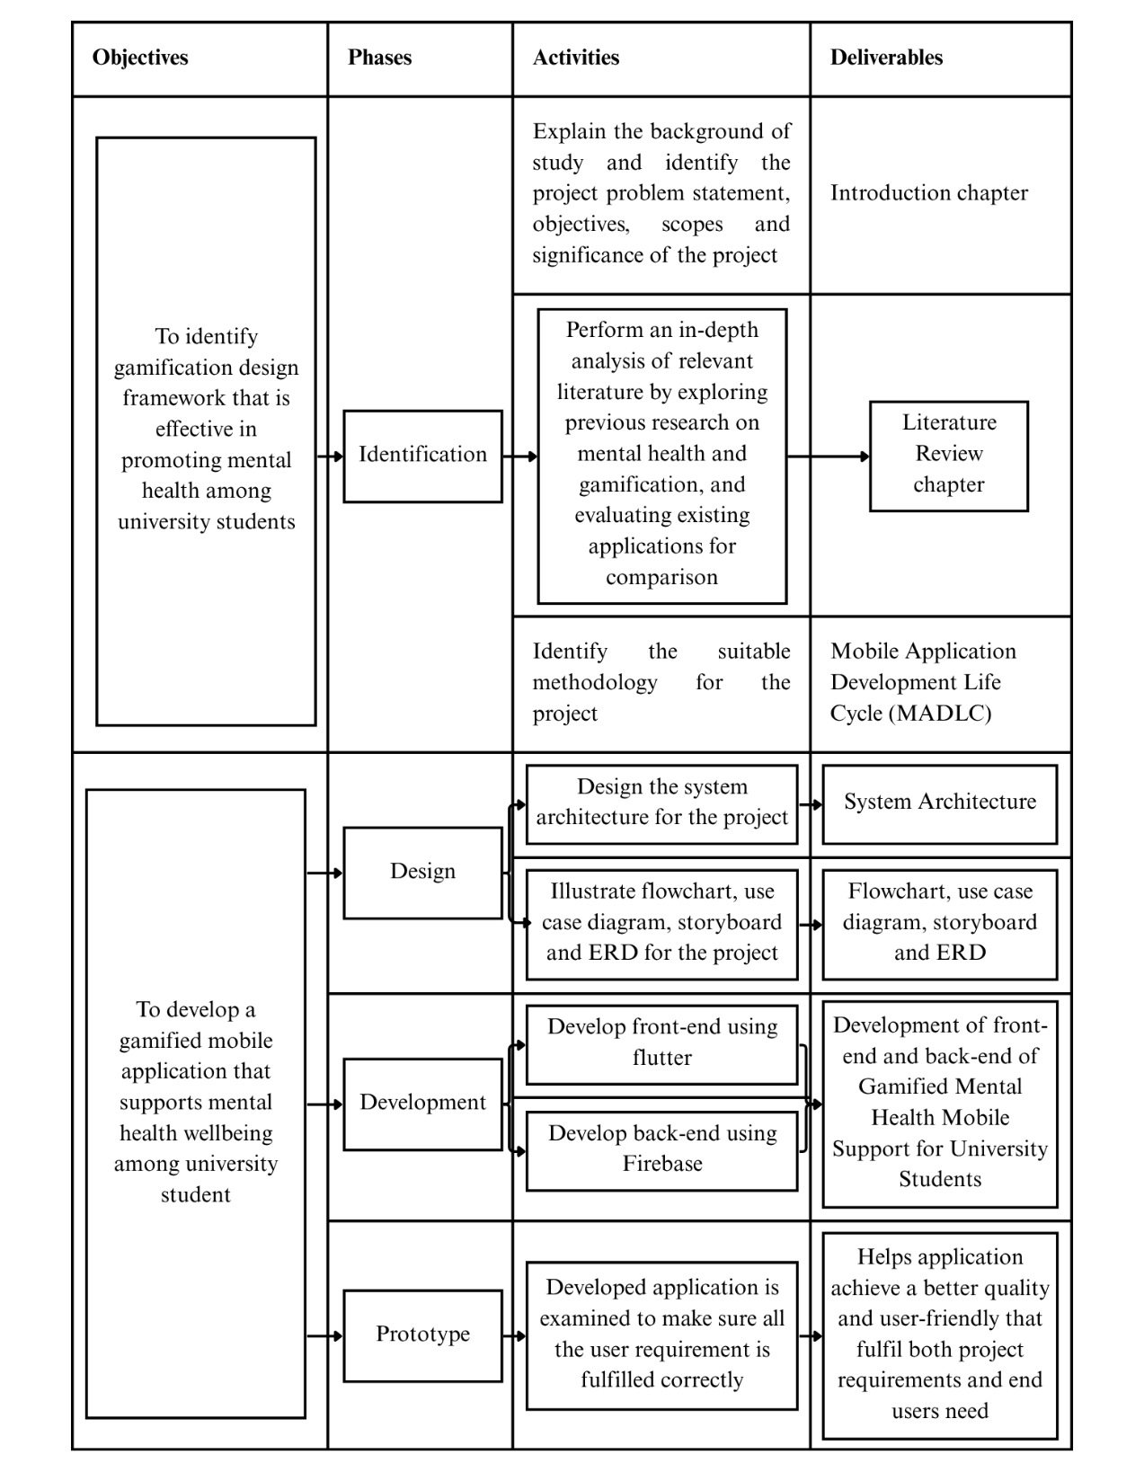

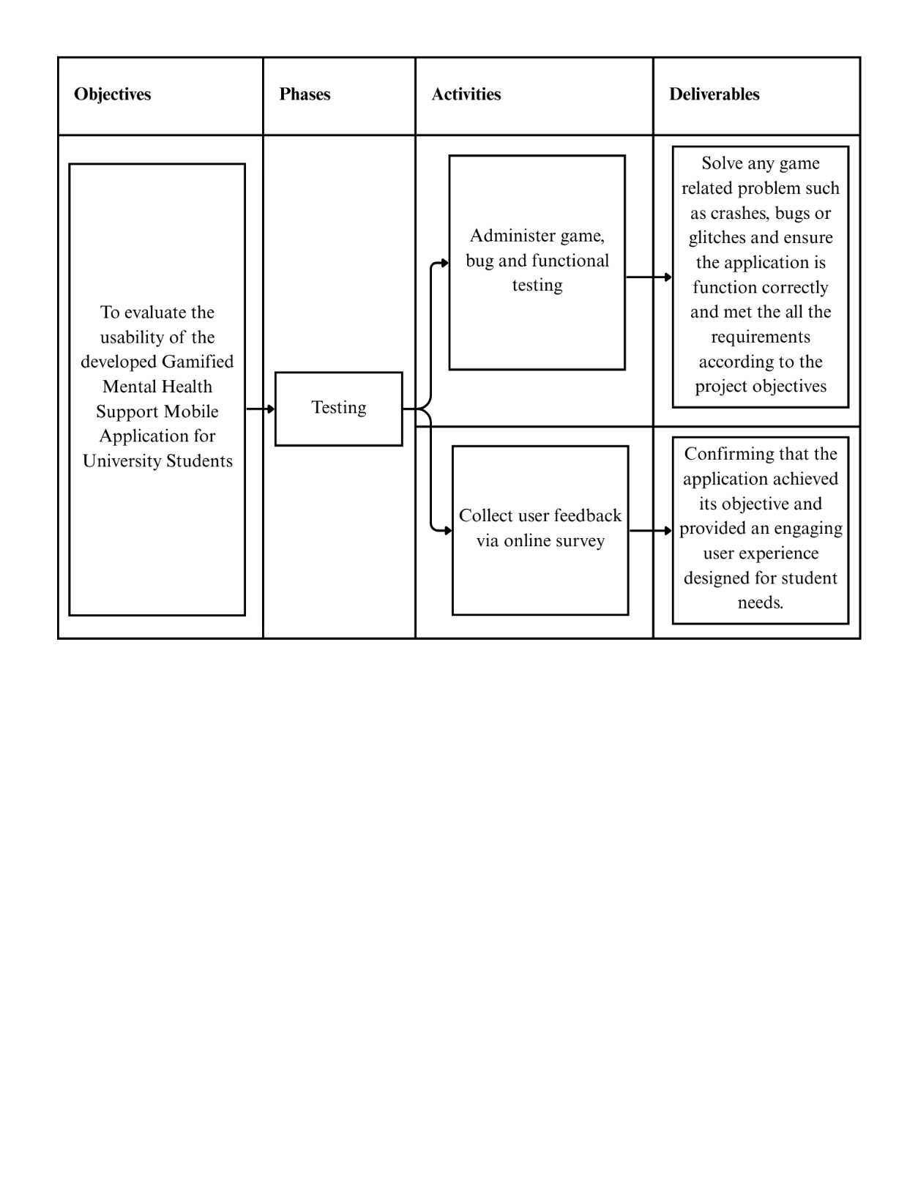

**3.4 System Architecture**

A software architecture is designed for this project to help the development of the application stays organized and streamlined as possible. Users begin their journey by logging in or registering, which leads to the main interface that includes key features such as Task, Journaling, Quizzes and DASS-21 Questionnaire. These elements work together to promote good mental health among university students. Figure 3.2 illustrates the system architecture of the Gamified Mental Health Support Mobile Application for University Students.

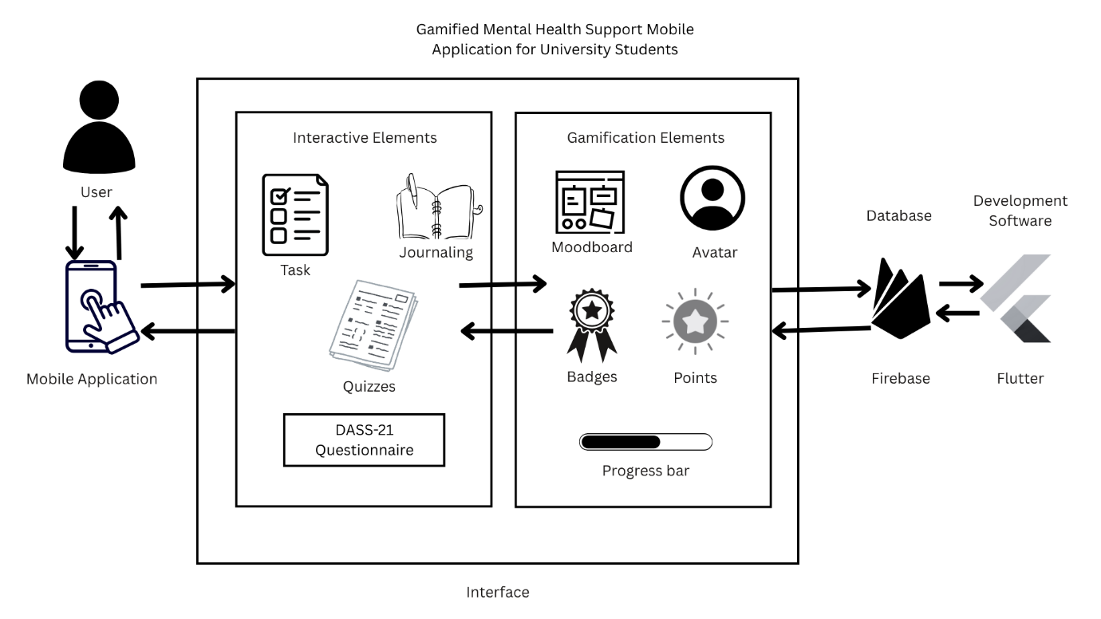

**Figure 3.2** System Architecture of the Gamified Mental Health Support Mobile Application for University Students

The application has several major features designed to support the mental health of college students in a way that is interactive and engaging for them. The journal module allows them to reflect and express themselves anonymously. Quizzes allow the students to gain knowledge about mental health. DASS-21 questionnaires, as in Appendix A, allow users to assess their own mental health status. The gamification feature includes avatars, moodboards, badges, points, and a progress bar that motivate users for daily use. These components work together to facilitate emotional awareness, daily self-check-ins, and healthy behavioral habits.  
  
 The architecture integrates frontend and backend components to deliver real-time functionality and secure data handling. Firebase supplies the cloud-based backend, managing user authentication, mood tracking, journaling, quiz responses, and gamification progress. The mobile application was developed with the assistance of Flutter, utilizing the Dart programming language to build an even, interactive, and engaging user interface. The primary development environment is Visual Studio Code, which offered inherent functionality for writing, testing, and debugging the application. Together, these technologies enable the development of a stable and user-friendly mobile application for mental health support.

**3.5 Hardware and Software Requirement**

Gamified Mental Health Support Mobile Application for University Students requires both hardware and software to be developed. The hardware requirement for this project are computer and smartphone to develop and test the application. The software requirement used for this project are online tools and database, applications and development kits for design, develop and to test the mobile application. The hardware and software requirements are discussed in this section.

**3.5.1 Hardware Requirement**

The required hardware for the development of this project is identified in the table below. The devices required for this project are computer and smartphone to develop and test the application. Table 3.7 list the specification and the description of the hardware needed for developing this application.

**Table 3.7** Hardware Requirement

|  |  |  |
| --- | --- | --- |
| Specification | Description | |
| Laptop | Smartphone |
| Name | Acer Nitro ANV15-51 | Xiaomi Redmi Note 12 Pro+ 5G |
| Processor | 13th Gen Intel(R) Core(TM) i5-13420H 2.10 GHz | Mediatek Dimensity 1080 (6 nm) |
| RAM | 16 GB | 8.0+4.0 GB |
| Operating System | Windows 11 Home Single Language | Android 14, Xiaomi Hyper OS |
| Function | To run the software tools and platforms that are required for creating, testing, and deploying mobile applications. | To test and run the mobile app during the development and testing process. |

The creation of the Gamified Mental Health Support Mobile Application for University Students relies on appropriate hardware to maintain a smooth and responsive development workflow. Adequate system capabilities were also essential in handling the demands of the development tools. An Acer Nitro ANV15-51 laptop function as the main workstation, offering the performance needed for writing, editing, and debugging code in Visual Studio Code. For mobile testing, a Xiaomi Redmi Note 12 Pro+ 5G smartphone was used to install and run the application, allowing developer to assess the app’s functionality and user interface on a physical device during each development stage.

**3.5.2 Software Requirement**

Software tools formed a crucial part of the development environment, providing the necessary platforms and functionalities to build and operate the Gamified Mental Health Support Mobile Application. Each software serves a specific purpose, supporting various stages of the project including design, development, testing, and deployment. These tools work in combination to ensure an efficient and cohesive workflow throughout the app development process. Table 3.8 outlines the software utilized in the project along with a description of the requirements.

**Table 3.8** Software Requirement

|  |  |
| --- | --- |
| Software | Description |
| Flutter | To develop the application front-end and run the code |
| Visual Studio Code | To write and debug the code for the application |
| Firebase | To develop the back-end services like to the application |
| Canva | To design system architecture and storyboard |
| Draw.io | To illustrate the erd and flowchart |
| Microsoft Word | To write all the documentation for the project |
| Mendeley Reference Manager | To cite all the references from researcch paper used for the project |

The software tools employed throughout the development process play essential role for this project. Flutter was used to build the front-end for the application. Whereas Visual Studio Code function as the main Integrated Development Environment (IDE) that helps code writing and debugging for the application to run as smooth as possible. Firebase serve as the back-end platform offering services that help back-end functionality. Canva was used for designing the system architecture and storyboard for this project. Draw.io helps to illustrate the ERD and flowchart for this application. Microsoft Word is used in preparing the project documentation, while Mendeley Reference Manager supported accurate citation and management of academic sources. The combined use of these tools ensure a streamlined development workflow and enhanced the overall quality and performance of the proposed application.

**3.6 Conclusion**

In summary, this chapter provided an in-depth explanation of the chosen methodology in developing the mobile application - the Mobile Application Development Life Cycle (MADLC). Each phase of the MADLC framework was thoroughly examined to offer a clear perspective on the development stages that was undertaken. The project methodology was also reviewed to highlight its role in ensuring the systematic and efficient progression of the project. Additionally, the system architecture was described and illustrated to show how the different components of the application interact with one another. The chapter concluded by outlining the required hardware and software, confirming that the necessary tools and platforms are available to support the development and functionality of the system. Overall, this chapter has established a groundwork for the following phases of the project.

**CHAPTER 4**

**PROJECT DESIGN, IMPLEMENTATION AND RESULT**

**4.1 Introduction**

This chapter presents a detailed report on the design, development, and testing phases of the Gamified Mental Health Support Mobile Application. The chapter begins by elaborating on the Project Design phase. This phase relies on a series of visual blueprints including the storyboard, use case diagram, flowchart, and Entity-Relationship Diagram to guide the technical architecture of the system. Following this, the Project Development section provides an in-depth explanation of how these designs were transformed into a fully functional application. The development process utilized Flutter for the frontend interface and Firebase for the backend database management. This section also highlights the specific integration of the Self-Determination Theory and the DASS-21 clinical assessment into the algorithm of the system. Finally, the chapter presents the findings from the Testing phase and the User Feedback survey. These results demonstrate the technical stability of the application and its effectiveness in promoting mental health engagement among university students.

**4.2 Project Design**

The design phase was a critical step in ensuring that the application was built with a logical structure and an intuitive user interface. This phase involved creating specific technical diagrams to visualize the user journey and the data flow of the system before the coding process began. By utilizing tools such as Canva for visual storyboards and diagrams.net for technical charts, the project established a clear and organized roadmap for development.

**4.2.1 Storyboard**

A storyboard was developed to provide a comprehensive visual narrative of the user interface. This graphical representation helped to identify the most efficient navigation flow for students to ensure that they could access support features quickly. It ensured that essential features such as the Dashboard, the DASS-21 assessment, and the Journaling tools were easily accessible without unnecessary steps. The storyboard maps out the complete progression of the user from the initial splash screen to the gamified profile. This planning process allowed for the early detection and resolution of potential usability issues.

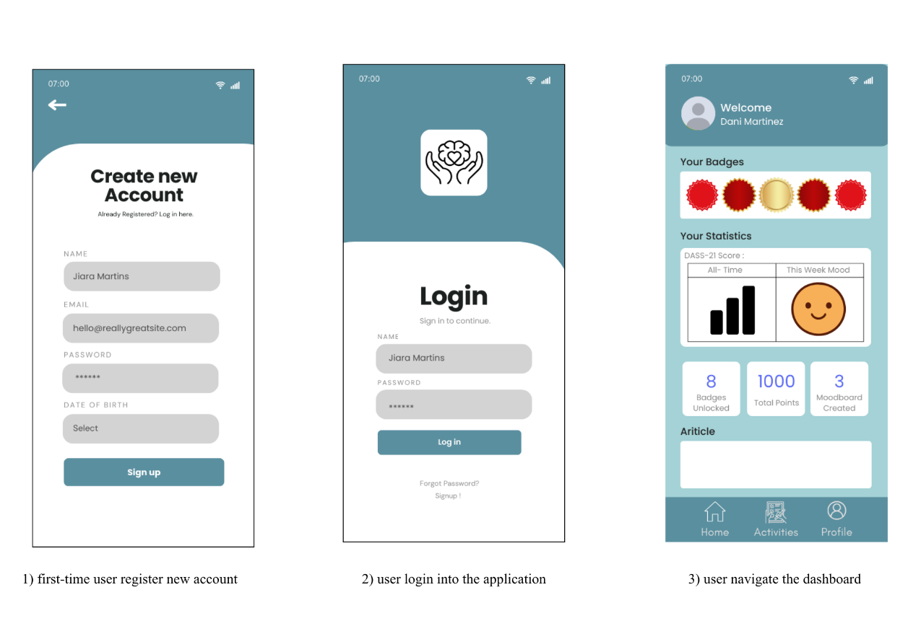

**Figure 4.1** Storyboard of Gamified Mental Health Support Mobile Application for University Students (Part 1)

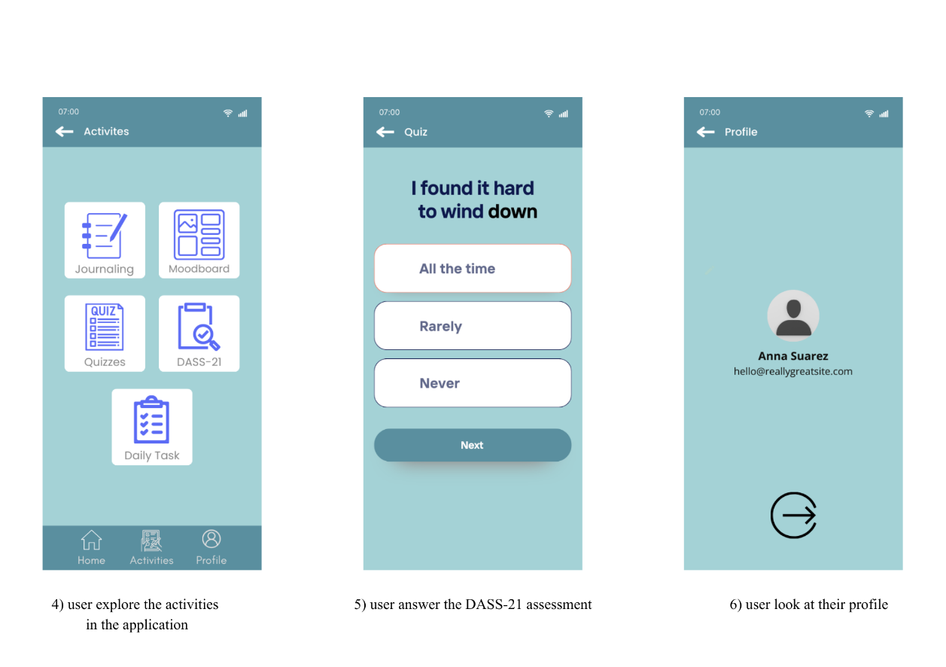

**Figure 4.2** Storyboard of Gamified Mental Health Support Mobile Application for University Students (Part 2)

**4.2.2 Use Case Diagram**

To clearly define the functional requirements of the system, a Use Case Diagram was constructed. This diagram visually delineates the interactions between the University Student, who acts as the primary actor, and the system itself. It categorizes the functions of the application into three core modules which are Profile Management, Self-Care Activities, and Gamification.

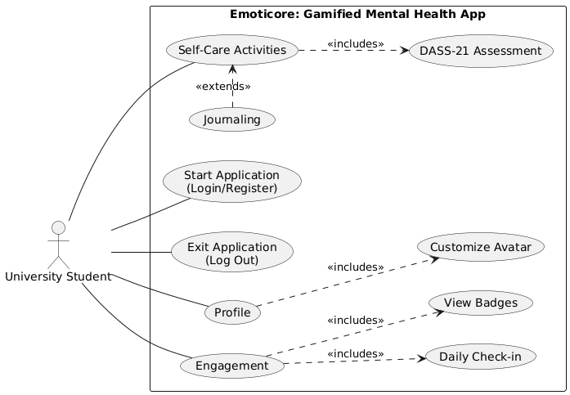

**Figure 4.3** Use Case Diagram of Gamified Mental Health Support Mobile Application for University Students

Figure 4.3 illustrates the Use Case Diagram for the Gamified Mental Health Support Mobile Application for University Students. The diagram categorizes the system's functionality into three primary modules accessible by the University Student: Profile, Self-Care Activities, and Engagement. The Profile module includes the Customize Avatar function, allowing users to personalize their identity using unlocked rewards. The Self-Care Activities module includes the DASS-21 Assessment as a core function for monitoring mental health, while Journaling extends this module by providing an optional space for deeper reflection. Finally, the Engagement module includes both the Daily Check-in and View Badges features, which utilize gamification to motivate consistent usage.

**4.2.3 Flowchart**

The flowchart provides a detailed and step-by-step visualization of the interaction pathway of the user within the application. This diagram maps the sequential logic required to navigate from the initial authentication screen to the utilization of specific internal features. By clearly outlining decision points, such as verifying if a user is logging in or registering for a new account, the flowchart ensures that the underlying logic of the application is sound and efficient.

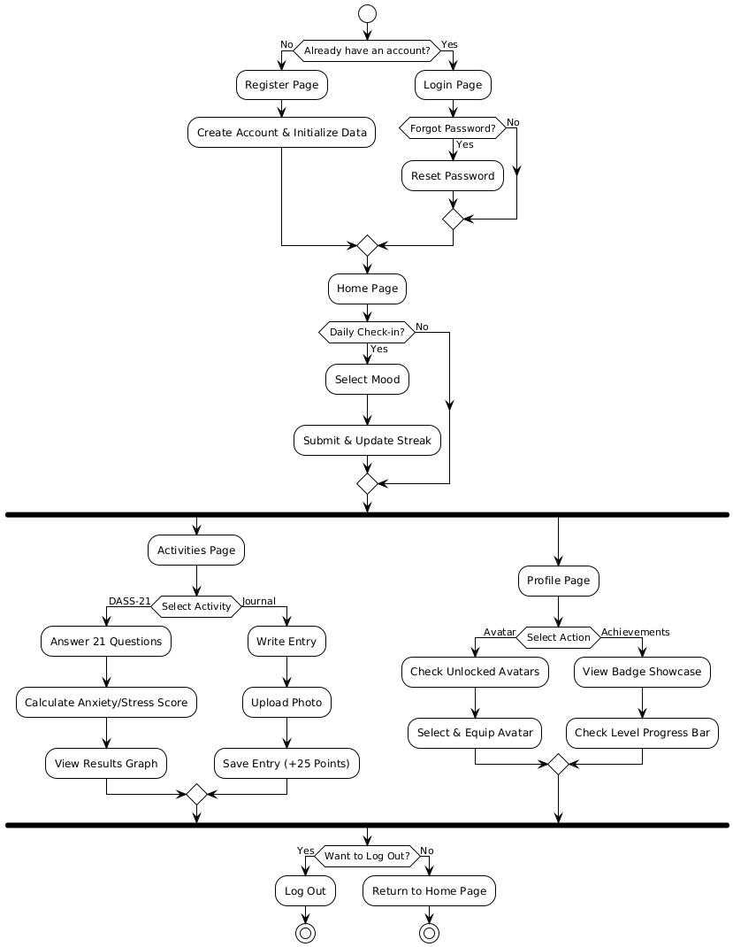

**Figure 4.****4** Flowchart of Gamified Mental Health Support Mobile Application for University Students

Figure 4.4 illustrates the operational flowchart of the Gamified Mental Health Support Mobile Application for University Students. The process begins with user authentication. Once on the dashboard, the user can select a self-care activity, Check-in, Assessment, or Journaling. Upon completion, the system saves the data to the Cloud Firestore database. Simultaneously, the Gamification Engine triggers to calculate the points earned for the specific task and update the user's total score. The system then performs a logic check: if the new total meets a specific threshold, it unlocks the corresponding Avatar or Badge and triggers a push notification. Finally, the user interface updates to reflect the new progress.

**4.2.4 Entity-Relationship Diagram (ERD)**

The Entity-Relationship Diagram visualizes the backend database structure of the application. It defines the relationships between the data entities to ensure that user information is stored efficiently and securely. Figure 4.5 shows that the User entity acts as the central data point or Primary Key. The diagram illustrates one-to-many relationships between the User and other subordinate entities including Journal Entries, Mood Logs, and DASS-21 Results. This structure allows the system to store a comprehensive and historical record of the activities of the user over time. Additionally, the diagram defines the relationship between Users and Badges which enables the gamification system to accurately track and display unlocked achievements.

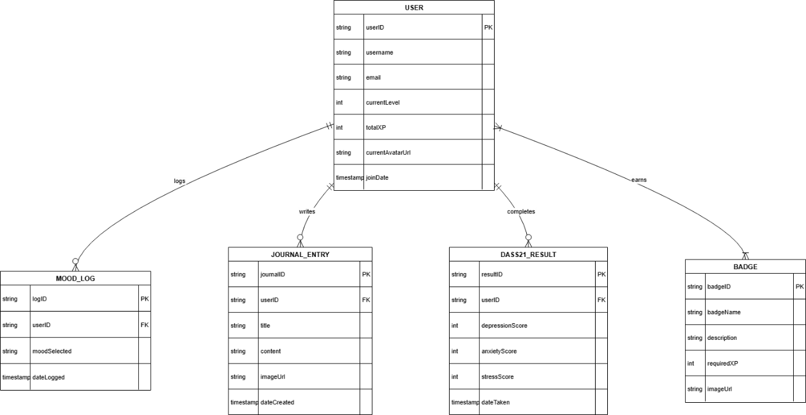

**Figure 4.5** Entity-Relationship Diagram of Gamified Mental Health Support Mobile Application for University Students

Figure 4.5 illustrates the Entity-Relationship Diagram of the application. The design centres on the User entity, which acts as the primary key that connects all other data tables. The diagram demonstrates one-to-many relationships between the User and the self-care modules, specifically for Journal Entries, Mood Logs, and DASS-21 Results. This structure allows the system to store a comprehensive history of the user's activities over time. Additionally, the diagram defines the relationship between Users and Badges to support the gamification logic. This ensures that the system can accurately track and award achievements based on the user's engagement.

**4.3 Project Development**

The development phase focused on translating the design documents into a fully functional mobile application. The project utilized Flutter as the primary development framework. This choice allowed for the creation of a high-performance cross-platform application that is compatible with various Android devices using a single codebase. Visual Studio Code was used as the Integrated Development Environment for writing, debugging, and testing the code. For the backend infrastructure, Firebase was selected to handle real-time database requirements, secure user authentication, and cloud-based media storage.

**4.3.1 Integration of Mental Health and Gamification**

A key aspect of the development was the integration of Self-Determination Theory to enhance user motivation and retention. The application was programmed to support the three psychological needs defined by the theory. First is Autonomy, where users are given the freedom to customize their profiles and choose which self-care activities to perform at their own pace. Second is Competence, where the system provides immediate feedback through dynamic progress bars, leveling systems, and scoring mechanisms. Third is Relatedness, where the application fosters a deeper connection to the personal mental health journey of the user.

Furthermore, the Depression, Anxiety, and Stress Scale was implemented as the core clinical tool. The application logic was coded to automatically calculate the final scores based on the standard scoring key. This is achieved by summing the relevant answers and multiplying the raw scores by two. This automatic calculation provides students with an instant and accurate summary of their mental state without manual effort.

**4.3.2 Developing Gamified Mental Health Support Mobile Application**

The Gamified Mental Health Support Mobile Application was developed using Flutter, a framework that enabled the creation of a cross-platform application with a single codebase, while Visual Studio Code served as the integrated development environment (IDE). Firebase was utilized for database management, providing essential backend services such as real-time data storage, user authentication, and data retrieval. Additionally, Canva was employed to design multimedia content, including the logo and badge graphics.

1. **Logo**

The Gamified Mental Health Support Mobile Application logo features a calming design that represents emotional balance and mental clarity. The design reflects the application's goal to promote mental health awareness through an accessible platform. This logo was designed using Canva. Figure 4.6 presents the logo of the application.



**Figure 4.6** Gamified Mental Health Support Mobile Application Logo

1. **Login and Signup Page**

The authentication module is responsible for managing user access and security. The Login Page requires users to enter a valid email and password. The system validates these credentials against the Firebase Authentication records to ensure data privacy. If the validation is successful, the user is directed to the Dashboard. Otherwise, an error message is displayed to guide the user.

The Signup Page facilitates the registration of new users. When a student creates an account, the code triggers two simultaneous actions. First, it creates a secure authentication record in Firebase. Second, it initializes a new document in the Firestore database. This document sets the starting statistics of the user to Level 1 and 0 XP. This initialization ensures that the gamification system is ready for use immediately upon the first login. Figure 4.7 showcases the application's registration and sign-in functionalities. Tables 4.1 and 4.2 detail the codes used for executing these functions.

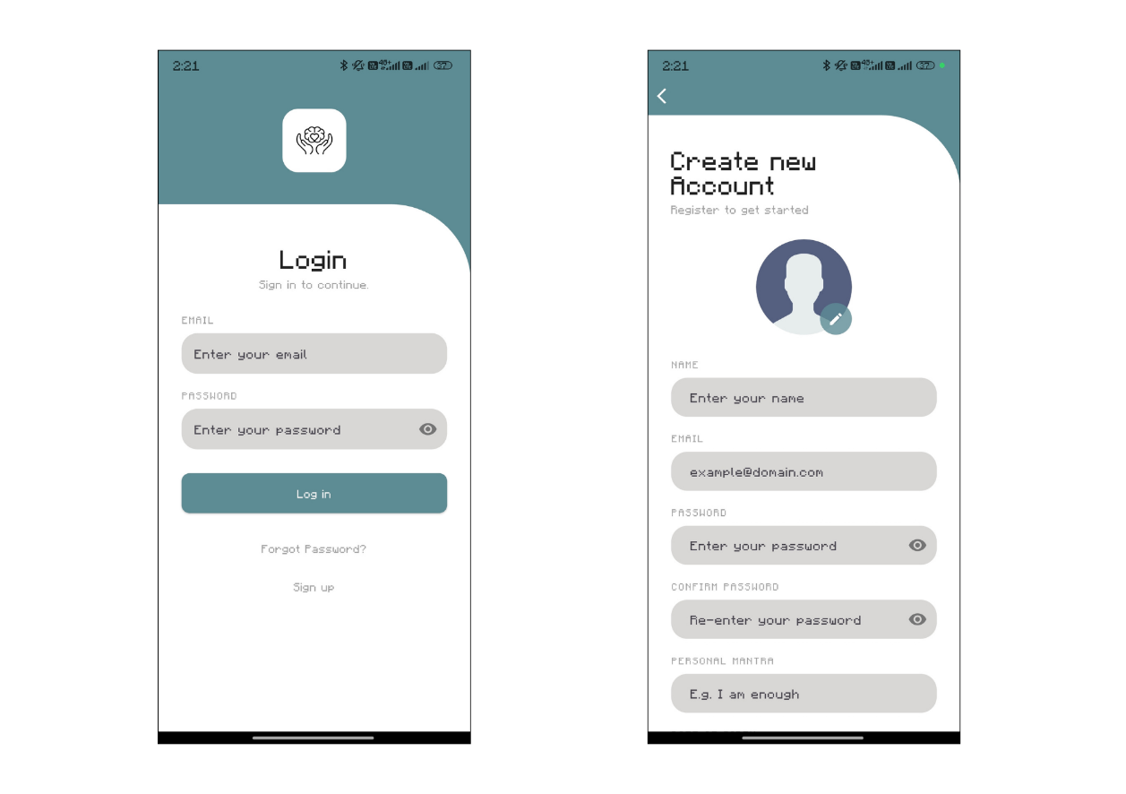

**Figure 4.7** Login and Signup Screen of Gamified Mental Health Support Mobile Application

**Table 4.1** Coding Snippets of Login Function for Gamified Mental Health Support Mobile Application

|  |  |
| --- | --- |
| Function | Description |
| loginUser | Authenticates the user using email and password. If the credentials are valid, it navigates the user to the Dashboard. If the login fails, it displays an error message to the user. |
| Code Snippet | try {  // --- 1. CAPTURE THE UserCredential ---  final userCredential = await FirebaseAuth.instance.signInWithEmailAndPassword(  email: _emailController.text.trim(),  password: _passwordController.text.trim(),  );  // --- 2. CHECK IF USER IS VALID ---  if (userCredential.user == null) {  throw FirebaseAuthException(code: 'null-user', message: 'Failed to sign in.');  }  if (dialogContext != null && Navigator.canPop(dialogContext!)) {  Navigator.pop(dialogContext!);  }    if (mounted) {  // --- 3. PASS THE USER TO THE CONSTRUCTOR ---  Navigator.pushReplacement(  context,  FadeRoute(page: EmoticoreMainPage(user: userCredential.user!)),  );  }  } on FirebaseAuthException catch (e) {  if (dialogContext != null && Navigator.canPop(dialogContext!)) {  Navigator.pop(dialogContext!);  }  if (mounted) {  ScaffoldMessenger.of(context).showSnackBar(  SnackBar(  content: Text(e.message ?? "Failed to sign in"),  backgroundColor: Colors.red,  ),  );  }  } catch (e) {  if (dialogContext != null && Navigator.canPop(dialogContext!)) {  Navigator.pop(dialogContext!);  }  if (mounted) {  ScaffoldMessenger.of(context).showSnackBar(  SnackBar(  content: Text("An unexpected error occurred: ${e.toString()}"),  backgroundColor: Colors.red,  ),  );  }  }  } |

**Table 4.2** Coding Snippets of Signup Function for Gamified Mental Health Support Mobile Application

|  |  |
| --- | --- |
| Function | Description |
| registerUser | Creates a new user account in Firebase Authentication. It also creates a corresponding document in the Firestore database to store user details and initialize their gamification level. |
| Code Snippet | try {        UserCredential userCredential =            await FirebaseAuth.instance.createUserWithEmailAndPassword(          email: _emailController.text.trim(),          password: _passwordController.text.trim(),        );          if (userCredential.user != null) {          await userCredential.user!.updateDisplayName(_nameController.text.trim());          // --- 1. FULL DATA INITIALIZATION ---          FirebaseFirestore firestore = FirebaseFirestore.instance;          await firestore.collection("users").doc(userCredential.user!.uid).set({            'name': _nameController.text.trim(),            'email': _emailController.text.trim(),            'dateOfBirth': _dateController.text.trim(),            'uid': userCredential.user!.uid,            'joinedAt': Timestamp.now(),            'selectedAvatarId': _selectedAvatarId,              // Initialize Gamification & Profile Stats            'currentStreak': 0,            'longestStreak': 0,            'lastCheckInDate': null,            'totalPoints': 0, // Start with 0 points            'unlockedBadges': [],            'selectedBadges': [],            'unlockedAvatars': [],            'mantra': _mantraController.text.trim().isEmpty                ? "One day at a time."                : _mantraController.text.trim(),          });          // --- END INITIALIZATION ---        } |

1. **Home Page (Dashboard)**

The Dashboard serves as the central hub of the application. It is designed to provide a quick and informative overview of the progress of the user. The interface displays the Daily Mood Check-in widget. This widget allows users to log their current emotional state with a single tap. This action triggers a function that updates the Streak count of the user in the database. The top section of the dashboard dynamically loads the current Avatar and Level of the user from Firestore. This provides immediate visual reinforcement of their gamification progress and encourages consistent use.

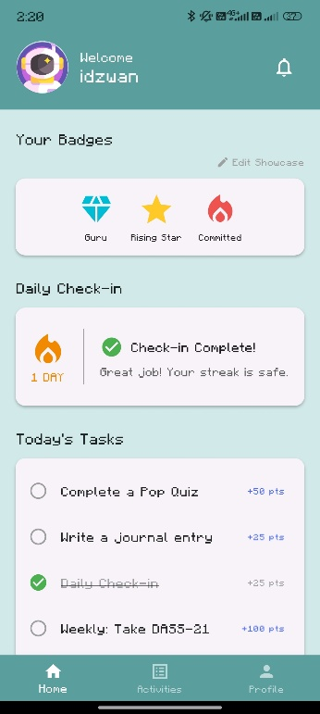

**Figure 4.8** Dashboard Screen of Gamified Mental Health Support Mobile Application

1. **Moodboard Page**

The Moodboard feature serves as a visual history of the user's emotional journey. While the "Daily Check-in" allows users to input their current mood, the Moodboard aggregates this data into a calendar or list view. This allows students to track their mood patterns over weeks or months, helping them identify triggers or improvements in their mental well-being. The data is fetched from the mood_logs collection in Firestore and displayed chronologically.

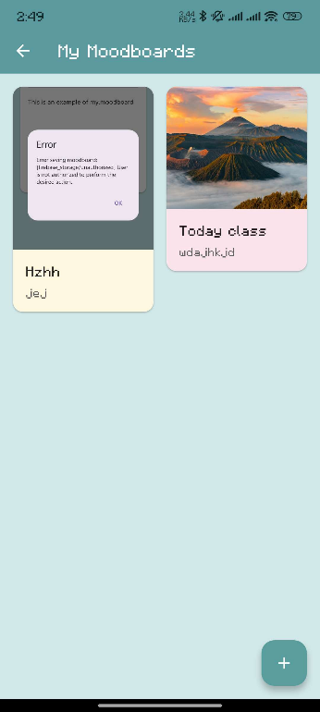

**Figure 4.9** Moodboard Screen of Gamified Mental Health Support Mobile Application

1. **DASS-21 Page**

The Dass-21 Page acts as a menu for the clinical tools of the application. The application presents the 21 standard questions using an intuitive slider or multiple-choice interface. Upon submission, the underlying code iterates through the list of answers provided by the user. It categorizes these answers into distinct groups for Stress, Anxiety, and Depression. The system then calculates the total score for each category by multiplying the raw sum by two. Finally, it saves a timestamped result object to the history of the user in Firestore. Figure 4.11 shows the assessment screen, and Table 4.3 provides the coding details for the calculation logic.

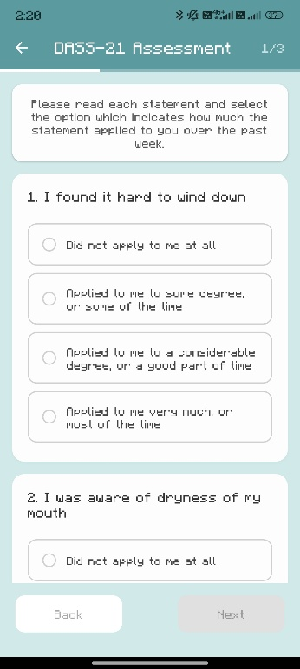

**Figure 4.10** DASS-21 Assessment Screen of Gamified Mental Health Support Mobile Application

**Table 4.3** Coding Snippets of DASS-21 Calculation for Gamified Mental Health Support Mobile Application

|  |  |
| --- | --- |
| Function | Description |
| calculateResult | Iterates through the user's selected answers. It groups the answers into categories for Stress, Anxiety, and Depression, calculates the total, and saves the result to Firestore. |
| Code Snippet | int depressionSum = 0;  int anxietySum = 0;  int stressSum = 0;  _answers.forEach((index, score) {  String scale = _questionIndexToScale[index]!;  switch (scale) {  case 'D':  depressionSum += score;  break;  case 'A':  anxietySum += score;  break;  case 'S':  stressSum += score;  break;  }  });  int finalDepressionScore = depressionSum * 2;  int finalAnxietyScore = anxietySum * 2;  int finalStressScore = stressSum * 2;  Map<String, int> answersWithStringKeys = _answers.map(  (key, value) => MapEntry(key.toString(), value),  );  User? currentUser = FirebaseAuth.instance.currentUser;  if (currentUser != null) {  showDialog(  context: context,  barrierDismissible: false,  builder: (context) => Center(  child: Lottie.asset(  'assets/animations/loading.json',  width: 150,  height: 150,  ),  ),  );  try {  await FirebaseFirestore.instance  .collection('users')  .doc(currentUser.uid)  .collection('dass21_results')  .add({  'depressionScore': finalDepressionScore,  'anxietyScore': finalAnxietyScore,  'stressScore': finalStressScore,  'timestamp': FieldValue.serverTimestamp(),  'rawAnswers': answersWithStringKeys,  });  // Save the completion time to SharedPreferences  final prefs = await SharedPreferences.getInstance();  await prefs.setString(  'lastDass21CompletionDate',  DateTime.now().toIso8601String(),  );  await GamificationService.awardPoints(currentUser, 100);  if (Navigator.canPop(context)) Navigator.pop(context); // Pop loading  // Show results dialog  _showResultsDialog(  finalDepressionScore,  finalAnxietyScore,  finalStressScore,  );  } catch (e) {  if (Navigator.canPop(context)) Navigator.pop(context); // Pop loading  print("Error saving DASS-21 results: $e");  ScaffoldMessenger.of(context).showSnackBar(  SnackBar(  content: Text('Error saving results: ${e.toString()}'),  backgroundColor: Colors.red,  ),  );  } |

1. **Mental Health Knowledge Quiz**

Distinct from the clinical assessment, the application features a Gamified Knowledge Quiz designed to educate students about mental health facts and myths. Unlike the DASS-21 which has no "right" or "wrong" answers, this feature tests the user's knowledge. The submitQuizAnswer function compares the user's selection against the correct answer stored in the database. If correct, the user is immediately rewarded with XP, reinforcing the learning process through positive reinforcement.

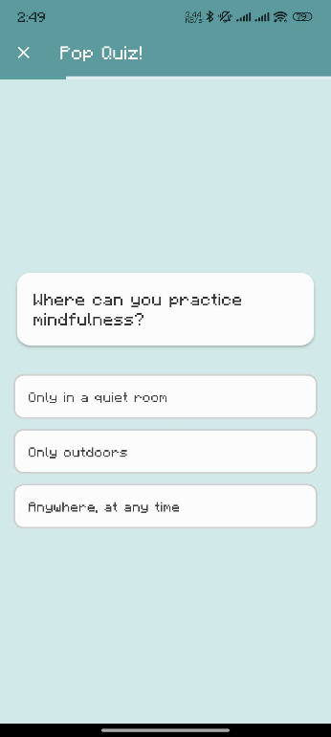

**Figure 4.11** Knowledge Quiz Screen of Gamified Mental Health Support Mobile Application

**Table 4.4** Coding Snippets of Knowledge Quiz for Gamified Mental Health Support Mobile Application

|  |  |
| --- | --- |
| Function | Description |
| checkAnswer | This function verifies the selected answer. It compares the selectedIndex with the correctAnswerIndex from the database. If they match, it calls the updateXP function to award points. |
| Code Snippet | void checkAnswer(int selectedIndex) {  if (selectedIndex == currentQuestion.correctIndex) {  showSuccessDialog();  updateXP(20); // Award 20 XP  } else {  showCorrectAnswer();  }  } |

1. **Journaling Page**

The Journaling feature provides a secure and private space for self-reflection. Users can enter a title and a descriptive body of text about their day. A key technical feature of this module is the Image Upload capability. The saveJournal function executes a two-step process. First, it uploads the selected image file to Firebase Storage to generate a secure and permanent download URL. Second, it links this URL with the text entry and saves the complete object to the journal collection of the user in Firestore. This method ensures that multimedia entries are handled efficiently without overloading the database. Figure 4.13 shows the journaling screen, and Table 4.5 provides the coding details for the journaling function.

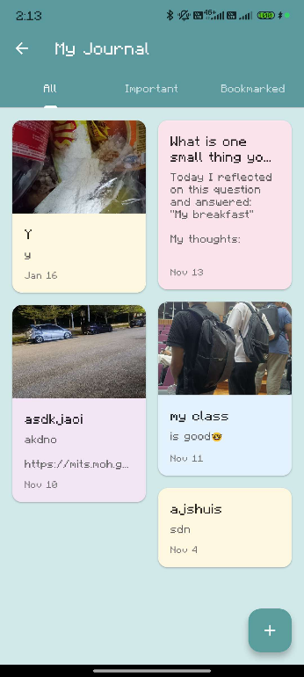

**Figure 4.12** Journal Entry Screen of Gamified Mental Health Support Mobile Application

**Table 4.5** Coding Snippets of Journal Function for Gamified Mental Health Support Mobile Application

|  |  |
| --- | --- |
| Function | Description |
| addJournalEntry | Uploads the selected image file to Firebase Storage to generate a download URL. It then creates a new document in the "journal" collection with the text and image data. |
| Code Snippet | try {  String? finalImageUrl = _existingImageUrl;    // Upload new image if picked  if (_pickedImageFile != null) {  String fileName = '${DateTime.now().millisecondsSinceEpoch}.jpg';  Reference storageRef = FirebaseStorage.instance  .ref()  .child('journal_images')  .child(user.uid)  .child(fileName);  UploadTask uploadTask = storageRef.putFile(_pickedImageFile!);  TaskSnapshot snapshot = await uploadTask;  finalImageUrl = await snapshot.ref.getDownloadURL();  }  else if (_imageWasRemoved) {  finalImageUrl = null;  }  final entryData = {  'title': _titleController.text,  'content': _contentController.text,  'timestamp': FieldValue.serverTimestamp(),  'userId': user.uid,  'isImportant': _isImportant,  'isBookmarked': _isBookmarked,  'imageUrl': finalImageUrl,  };  if (_documentId == null) {  // --- NEW ENTRY ---  await FirebaseFirestore.instance.collection('users').doc(user.uid)  .collection('journal_entries').add(entryData);    // --- GAMIFICATION: Award 25 Points ---  await GamificationService.awardPoints(user, 25);    } else {  // --- EXISTING ENTRY ---  await FirebaseFirestore.instance.collection('users').doc(user.uid)  .collection('journal_entries').doc(_documentId).update(entryData);  } |

1. **Gamification and Badge System**

The Gamification Engine runs in the background to continuously track user engagement. Whenever a user completes a task such as a quiz or journal entry, the updateXP function adds experience points to their profile. Instead of a separate screen, the application utilizes an interactive Badge Dialog accessible from the Dashboard or Profile. When a user reaches a new level, a new badge is unlocked in the database. Users can then open the selection popup to choose which earned badge they wish to display next to their avatar. This integration keeps the user interface clean while still providing motivating rewards.

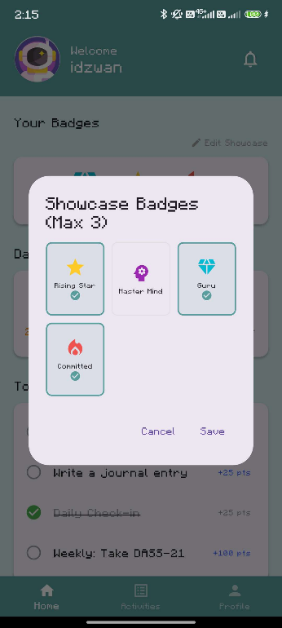

**Figure 4.13** Badge selection popup of Gamified Mental Health Support Mobile Application

1. **Profile Page**

The Profile Page allows users to view their personal statistics and customize their virtual identity. The Avatar Selection feature is directly tied to the gamification logic. Users are only permitted to select avatars that they have successfully unlocked through leveling up. The page also provides access to the historical data of the user. This allows them to review past journal entries and quiz results to track their mental health journey over time. Figure 4.15 depicts the profile screen where users can view and edit their personal information and select their avatar. The Avatar function lets users select and update their character from a list of unlocked assets. The coding aspects for the gamification logic are outlined in Table 4.6.

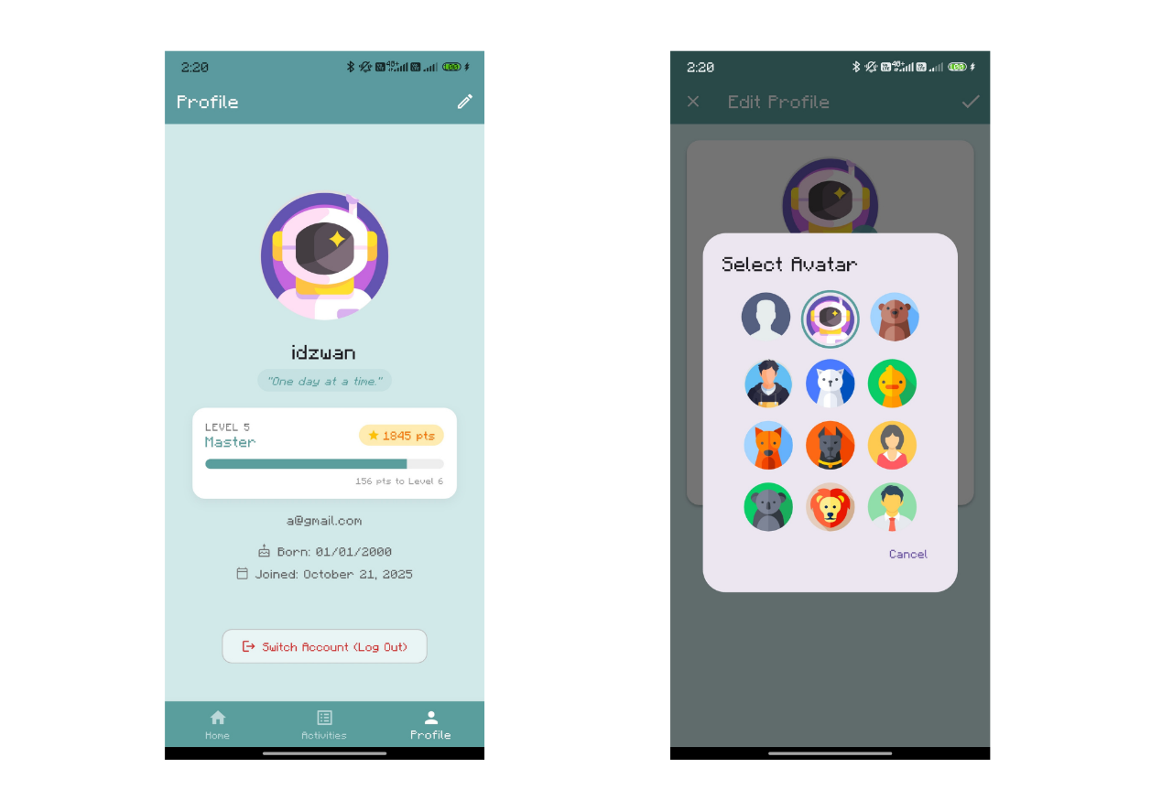

**Figure 4.14** Profile Page and Avatar Selection of Gamified Mental Health Support Mobile Application

**Table 4.6** Coding Snippets of Gamification Logic for Gamified Mental Health Support Mobile Application

|  |  |
| --- | --- |
| Function | Description |
| checkLevelUp | Checks if the user's current XP has reached the threshold for the next level. If true, it increments the level and unlocks the corresponding badge. |
| Code Snippet | static Future<void> checkAchievements(User? user) async {  if (user == null) return;  final userRef = FirebaseFirestore.instance.collection('users').doc(user.uid);  final doc = await userRef.get();    if (!doc.exists) return;  final data = doc.data()!;  final int currentPoints = data['totalPoints'] ?? 0;  final int currentStreak = data['currentStreak'] ?? 0;    bool needsUpdate = false;  // --- CHECK BADGES ---  List<String> unlockedBadges = List<String>.from(data['unlockedBadges'] ?? []);    for (var badge in allBadges) {  if (unlockedBadges.contains(badge.id)) continue;  bool earned = false;  // Check if XP (points) reached the threshold  if (badge.requiredPoints > 0 && currentPoints >= badge.requiredPoints) earned = true;  if (badge.requiredStreak > 0 && currentStreak >= badge.requiredStreak) earned = true;  if (earned) {  unlockedBadges.add(badge.id); // Unlock corresponding badge  needsUpdate = true;    await NotificationService.addNotification(  uid: user.uid,  title: "New Badge Unlocked!",  body: "You've earned the '${badge.name}' badge. Great job!",  type: 'badge',  );  }  }    // ... (Avatar unlock logic follows similar pattern)  if (needsUpdate) {  await userRef.update({  'unlockedBadges': unlockedBadges,  // ...  });  }  } |

**4.4 Testing**

The third objective was to test the functionality of the Gamified Mental Health Support Mobile Application to ensure that all features and functions operated as intended. Testing was essential to verify the application’s functionality, performance, reliability, and usability. It helped identify possible system issues and vulnerabilities during development to ensure application consistency and improve user satisfaction. Table 4.6 lists the components evaluated during the testing process. Each component underwent close inspection to verify proper operation and alignment with project objectives.

**Table 4.7** Functionality Testing of Gamified Mental Health Support Mobile Application

|  |  |  |  |  |
| --- | --- | --- | --- | --- |
| Functionality | Description | Testing Steps | Expected Result | Pass/Fail |
| Login | Allows users to log into their accounts using email and password. | Enter valid email and password. | User is logged in successfully and directed to Dashboard. | Pass |
| Signup | Enables new users to create accounts. | Enter valid details and submit. | User account is created and data initialized in Firestore. | Pass |
| Daily Check-in | Tracks mood and daily streak. | Select a mood emoji and click save. | Streak counter increases by 1 and points are added. | Pass |
| DASS-21 | Mental health assessment quiz. | Answer all 21 questions and submit. | Score is calculated and results graph is updated. | Pass |
| Journaling | Enables users to create and save journal entries. | Write text, add photo, and save. | Entry is saved and success message is displayed. | Pass |
| Gamification | Level up system. | User earns 100 XP points. | Level changes from 1 to 2 and new avatar unlocks. | Pass |

**4.5 User Feedback**

A User Acceptance Test was conducted to evaluate the experience of the user with the application. A total of 34 university students attempted to participate in the testing phase. Out of this group, 31 participants successfully installed the application and completed the full testing cycle. These participants used the application on their Android devices and subsequently completed a survey to provide feedback on usability, design, and motivation.

**4.5.1 Demographic Data**

The demographic data provides insight into the background of the respondents. The analysis of the 31 valid responses shows that the majority of the participants were between the ages of 21 and 23. This group represented 64.5% of the total respondents. The remaining participants consisted of students aged 24 and above which made up 25.8% of the group and students aged 18 to 20 who comprised 9.7%. Regarding gender distribution, the group consisted of 61.3% Male and 35.5% Female participants while one participant chose not to specify. This data confirms that the testing group represents a diverse cross-section of the university population.

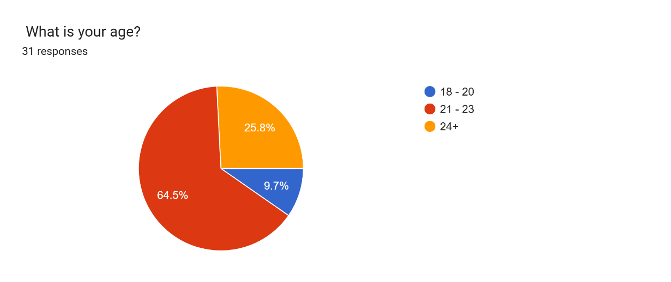

**Figure 4.15** Age Distribution

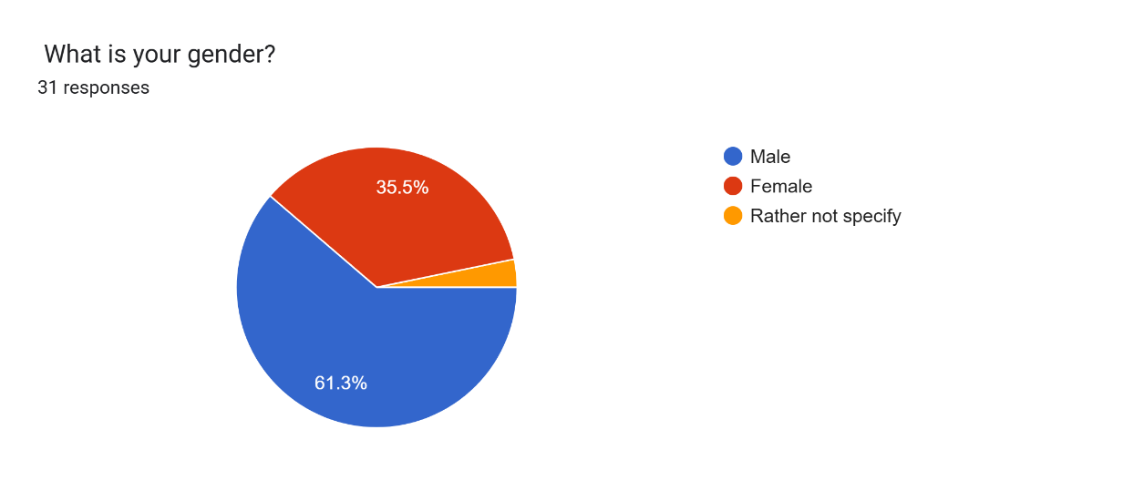

**Figure 4.16** Gender Distribution

**4.5.2 Ease of Use**

The survey assessed the intuitiveness of the interface by asking users to rate the ease of navigation on a scale of 1 to 5. The results were positive as 71.0% of the students rated the application a perfect 5 out of 5 for ease of use. Another 25.8% of students rated it a 4 out of 5 while 3.2% gave a rating of 3 out of 5. No participants gave a rating below 3. This demonstrates that the navigation flow of the application is logical and generally accessible to users.

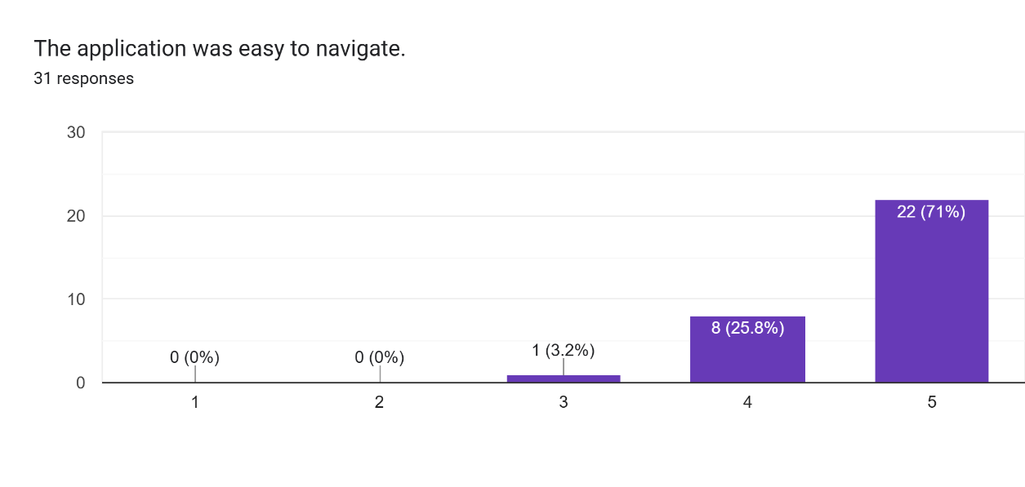

**Figure 4.17** User feedback on ease of use

**4.5.3 Motivation and Gamification**

A primary objective of the project was to determine if gamification elements effectively engage users. When asked if the Leveling Up and XP systems motivated them to complete tasks, 67.7% of students responded that it was very motivating. Another 29% of the students found it somewhat motivating while only 3.2% indicated that they did not care about the points. Furthermore, the majority described their feeling as excited or accomplished when unlocking new avatars or badges. These findings validate the implementation of the Self-Determination Theory in driving user engagement.

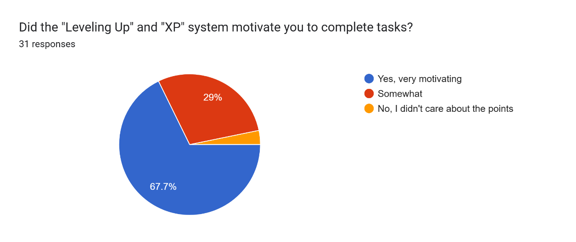

**Figure 4.18** User feedback on motivation and gamification (Part 1)

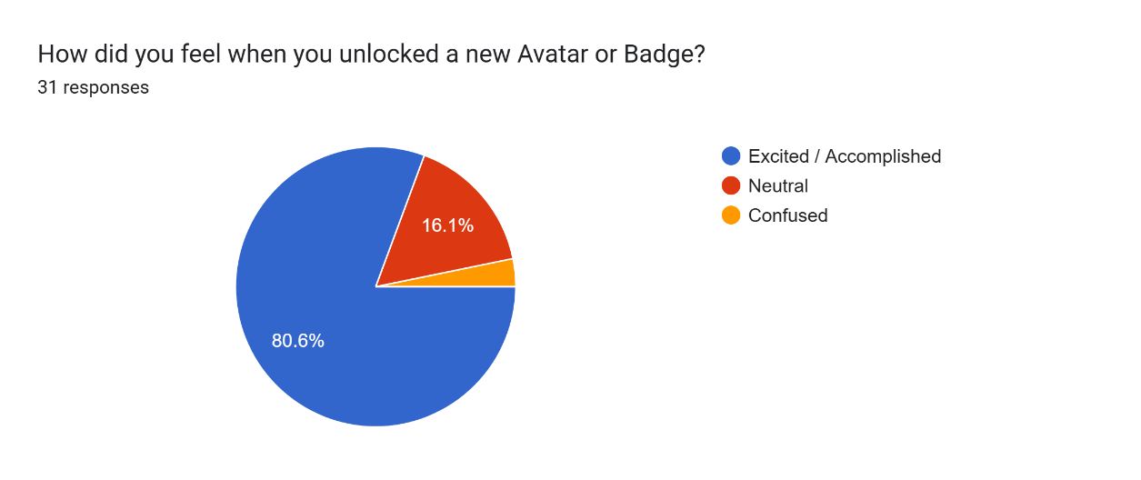

**Figure 4.19** User feedback on motivation and gamification (Part 2)

**4.5.4 Overall Satisfaction and Qualitative Feedback**

The overall satisfaction rate was calculated based on a 5-point scale. The results show that 64.5% of the students rated their overall experience as 5 out of 5 while 25.8% rated it 4 out of 5. A minority of 9.7% gave a rating of 3 out of 5.

In terms of qualitative feedback, the majority of users reported positive experiences. However, some participants provided constructive suggestions to improve the application. One student suggested adding moving characters or GIF animations to better grasp the attention of the user. Another user recommended creating an initial tutorial to help new users understand the features. Additionally, one recent respondent noted a limitation regarding the camera integration for journal entries and suggested enabling direct photo capture. These suggestions highlight valuable opportunities for future system enhancements.

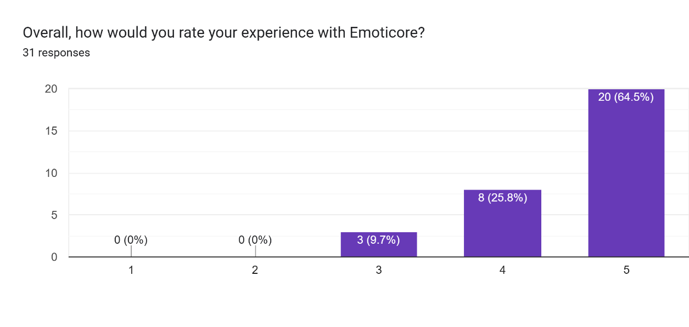

**Figure 4.20** User feedback on overall satisfaction

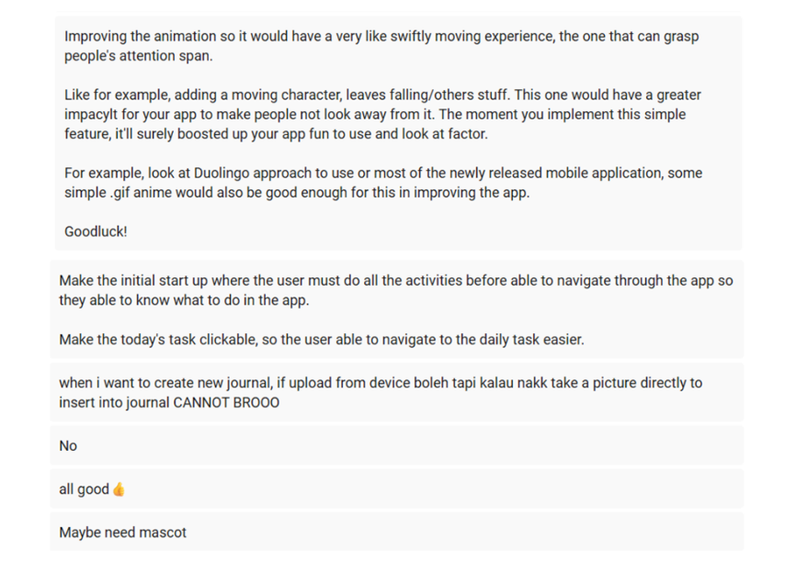

**Figure 4.****21** Some of user suggestion for improvement

**4.6 Conclusion**

This chapter has presented a detailed overview of the implementation and results of the Gamified Mental Health Support Mobile Application. The process began with a comprehensive design phase where visual models such as the Use Case Diagram and Entity-Relationship Diagram were used to structure the system logic. This planning stage ensured that the subsequent development phase proceeded efficiently.

During the development phase, the application was successfully built using Flutter for the user interface and Firebase for backend services. Key features were implemented to address the project objectives. These included the DASS-21 assessment for tracking mental health status and a gamification engine based on Self-Determination Theory to enhance user motivation. The integration of these elements resulted in a functional application that provides both clinical insight and engaging rewards.

The final stage of this chapter reported the findings from the functionality testing and User Acceptance Test. The functional testing confirmed that all core modules operate correctly and are free from critical errors. Furthermore, the feedback from the user survey demonstrated that the application is well-received by the target audience. The high satisfaction ratings and positive responses regarding the gamification features indicate that the application successfully meets the needs of university students. In summary, the results validate that the project has achieved its primary objectives of designing, developing, and testing a mobile application that effectively supports student mental well-being.

**CHAPTER 5**

**CONCLUSION AND RECOMMENDATIONS**

**5.1 Introduction**

This chapter discusses a summary of the entire research project. It focuses on the achievement of the research objectives as explored through the analysis and findings sections. It reflects on the effectiveness of the project in meeting its goals and examines how the designed application has contributed to the enhancement of mental health awareness for university students. The discussion covers the methods employed, the results obtained, and the overall impact of the Gamified Mental Health Support Mobile Application. Additionally, this chapter identifies the limitations encountered during the research and addresses issues that affected the execution and outcomes of the project. Based on these limitations, it offers thoughtful recommendations for future improvements to enhance both the effectiveness and the user experience of similar health technology tools.

**5.2 Overall**

The mobile application for university students was systematically developed using the Mobile Application Development Lifecycle methodology. This provided a structured approach to ensure the success of the project. The development process began with a thorough identification phase where the research area was defined, problem statements were articulated, and clear objectives were established. Following the identification phase, an extensive literature review was conducted to deepen the theoretical foundations of the project. This review incorporated insights from existing academic research on Self-Determination Theory and the DASS-21 assessment which informed the design and implementation of the app.

During the design phase, various tools and methodologies were employed to ensure a comprehensive and effective development process. A detailed system architecture outlined the overall structure of the app while storyboards created with Canva visually represented the user interface. Diagrams.net was utilized to define the use case, create the flowchart, and develop the Entity-Relationship Diagram. The use case illustrated the functionality from the perspective of the student while the flowchart mapped out the logic and processes such as the daily mood check-in and quiz submission. Additionally, the Entity-Relationship Diagram was developed to structure the database schema in Cloud Firestore to ensure effective data management.

Development utilized Visual Studio Code and the Flutter framework to ensure a sophisticated user experience and robust backend features through Firebase. The prototyping and testing phase involved rigorous functionality testing and user feedback to evaluate usability. This was essential for optimizing the performance of the app. The primary objective was to create an engaging and effective mental health platform for university students by leveraging gamification to enhance engagement. This systematic approach ensured that the app was both clinically relevant and user-friendly.

**5.3 Objective**

This research project aims to fulfil three main objectives which have been outlined in detail below to provide a clearer and more comprehensive understanding of the goals and achievements of the project.

**5.3.1 First Objective**

The first objective was to identify a gamification design framework that is effective in promoting mental health engagement among university students. This objective was achieved through a comprehensive literature review and analysis of existing mental health applications. The chosen theoretical framework was the Self-Determination Theory which guided the creation of the functions of the mobile application. This theory focuses on three psychological needs which are Autonomy, Competence, and Relatedness. By applying this framework, the application was designed with game elements such as customizable avatars to support Autonomy and progress bars with badges to support Competence. This approach ensured that the app was effective in motivating students to perform self-care activities such as journaling and taking the DASS-21 assessment.

**5.3.2 Second Objective**

The second objective was to develop a gamified mental health support mobile application that covers core aspects of mental well-being tailored to the needs of university students. This objective was achieved by developing an app using the Flutter framework to ensure the development of a robust user interface with calming graphics and student-friendly content. The application incorporated features such as the DASS-21 clinical assessment which calculates scores for Depression, Anxiety, and Stress automatically. Additionally, the app was designed with features like the Daily Mood Check-in, the Moodboard for tracking emotional history, the Mental Health Knowledge Quiz, and Journaling to create a supportive environment where students can monitor their emotional state through an engaging and accessible platform.

**5.3.3 Third Objective**

The third objective was to evaluate the functionality of the developed gamified mental health app to ensure it met design specifications and effectively supported the well-being of the users. This was achieved through extensive functionality testing to verify that all features worked as intended. The integration of Firebase provided essential backend services such as secure user authentication and real-time database storage. Additionally, a survey was used to gather feedback from 31 university students on their user experience, feature enjoyment, and motivation levels. Insights from the survey indicated high levels of satisfaction and confirmed that the gamification elements successfully motivated students to engage with the application daily.

**5.4 Limitations**

During the testing and analysis of the project, several limitations were encountered. Firstly, compatibility issues restricted access for users with iOS devices as the application was compiled as an APK specifically for the Android operating system. Additionally, the reliance of the app on a consistent internet connection presented issues for users in areas with unstable connectivity. Users could not save journal entries or retrieve their badges without an active data connection to Firebase. Moreover, the current gamification content is static. The badges and avatars are hard-coded into the application which means that once a user unlocks all available rewards, there is no new content to maintain long-term motivation. Finally, the app lacks direct integration with professional counselling services which limits its ability to provide immediate help in severe cases identified by the DASS-21 assessment.

**5.5 Recommendations**

In the future, the project should consider several enhancements to improve the functionality and user experience of the app. Although the current application offers significant value to university students, these recommendations aim to address existing limitations and introduce new features for a more comprehensive experience. Some functions that need to be considered for future improvement include:

1. **Implementation of Offline Mode**

Allow users to access content and perform activities such as journaling without an internet connection. This would require implementing local storage that synchronizes with the online database once the connection is restored.

1. **Cross-Platform Deployment**

Expand the availability of the application to include iOS devices. This would ensure that the application is accessible to a wider population of university students regardless of their mobile device preference.

1. **Integration of Professional Support**

Add a feature that connects students directly with university counsellors or mental health helplines. This could include a panic button or a directory that becomes visible if the DASS-21 score indicates a high level of stress or depression.

1. **Dynamic Content Updates**

Develop a system to update challenges and badges remotely without requiring a full app update. This would allow for seasonal events or new themes to keep the application fresh and engaging for long-term users.

**5.6 Conclusion**

In conclusion, the research into the development of a gamified mental health support mobile application for university students has proven effective in enhancing engagement with self-care practices. The project successfully met its three main objectives. First, it identified an effective design framework based on Self-Determination Theory and the DASS-21 assessment. Second, it developed a functional and user-friendly application using Flutter and Firebase that included key features like mood tracking, the knowledge quiz, and journaling. Third, it evaluated the functionality of the app through extensive testing and user feedback which confirmed its stability and appeal to the target audience. Despite challenges related to internet dependency and platform compatibility, the app provided a robust platform for mental health monitoring. Future recommendations include implementing offline access, expanding platform availability, and integrating professional support features to further improve the effectiveness and safety of the application.

**REFRENCES**

Ahmad Fuad, N. A., Mohd Rizuan, Y., Ramli, N. A. N., Heitin, F. S., A/P Ravindran, D., Binti Hussin, N. A. A., & Aminuddin Jafry, N. H. (2024). Stress Factors among University Students: A Case Study at Universiti Kebangsaan Malaysia. *International Journal of Academic Research in Business and Social Sciences*, *14*(11). https://doi.org/10.6007/IJARBSS/v14-i11/21956

Amin, S. M., Ibrahim, N. F., Nazuri, N. S., & Ahmad Suhaimi, S. S. (2024). The Relationship between Social Supports on Mental Health among University Students in Klang Valley. *International Journal of Academic Research in Business and Social Sciences*, *14*(8). https://doi.org/10.6007/ijarbss/v14-i8/22301

Arifin, S., Abdullah, S. S., Omar, N. E., Mohamed, N., Yusop, Y. M., & Hamdul Hadi, N. M. (2023). The Prevalence of Mental Health among Malaysian University Students. *International Journal of Academic Research in Business and Social Sciences*, *13*(12). https://doi.org/10.6007/ijarbss/v13-i12/19796

Aydınlıyurt, E. T., Taşkın, N., Scahill, S., & Toker, A. (2021). Continuance intention in gamified mobile applications: A study of behavioral inhibition and activation systems. *International Journal of Information Management*, *61*. https://doi.org/10.1016/j.ijinfomgt.2021.102414

Barbayannis, G., Bandari, M., Zheng, X., Baquerizo, H., Pecor, K. W., & Ming, X. (2022). Academic Stress and Mental Well-Being in College Students: Correlations, Affected Groups, and COVID-19. *Frontiers in Psychology*, *13*. https://doi.org/10.3389/fpsyg.2022.886344

Bete, T., Misgana, T., Nigussie, K., Aliye, K., Abdeta, T., Wedaje, D., Hunduma, G., Assefa, A., Tesfaye, D., Asfaw, H., Amano, A., Tariku, M., Dereje, J., Ali, T., Mohammed, F., Demissie, M., Mohammed, A., Hayru, N., Assefa, B., … Alemu, D. (2024). Depressive disorder, bipolar disorder, and associated factors among adults, in the Eastern part of Ethiopia. *BMC Psychiatry*, *24*(1). https://doi.org/10.1186/s12888-023-05466-5

Boucher, E. M., Ward, H. E., Stafford, J. L., & Parks, A. C. (2021). Effects of a digital mental health program on perceived stress in adolescents aged 13-17 years: Protocol for a randomized controlled trial. *JMIR Research Protocols*, *10*(4). https://doi.org/10.2196/25545

Brownlow, L. (2022). Targeting the Needs of Self-Determination Theory: An Overview of Mental Health Care Apps. In *European Journal of Mental Health* (Vol. 17, Issue 1, pp. 91–100). Semmelweis University Institute of Mental Health. https://doi.org/10.5708/EJMH/17.2022.1.8

Castellano-Tejedor, C., & Cencerrado, A. (2024). Gamification for Mental Health and Health Psychology: Insights at the First Quarter Mark of the 21st Century. *International Journal of Environmental Research and Public Health*, *21*(8). https://doi.org/10.3390/ijerph21080990

Cheng, C., & Ebrahimi, O. V. (2023). Gamification: a Novel Approach to Mental Health Promotion. In *Current Psychiatry Reports* (Vol. 25, Issue 11, pp. 577–586). Springer. https://doi.org/10.1007/s11920-023-01453-5

Chou, Y. (2016). *The Octalysis Framework for Gamification & Behavioral Design*. https://yukaichou.com/gamification-examples/octalysis-complete-gamification-framework/

Cremaschi, M., Avis, G. R., Zhao, A. Q., Guarnieri, E., Panzeri, A., & Spoto, A. (2025). PENguIN: A mental health application employing gamification and token economy to boost therapeutic adherence in young users. *Computers in Human Behavior Reports*, *17*. https://doi.org/10.1016/j.chbr.2025.100586

Das, P., Kumar, S., & Chidambaram, R. (2023). Depression, Anxiety and Stress Level Among University Students in India During COVID-19 Outbreak. In *Malaysian Journal of Medicine and Health Sciences* (Vol. 19, Issue SUPP20).

*eQuoo for Students - PsycApps*. (2025). https://psycapps.com/equoo-for-students/

Herfurth, H. (2025). *Blazer-created mental health app puts wellness in student hands - Student Affairs - Student Affairs News*.

Hunicke, R., Leblanc, M., & Zubek, R. (2004). *MDA: A Formal Approach to Game Design and Game Research*.

Jarche, H. (2014, September 17). *Self-determination at work – Harold Jarche*. https://jarche.com/2014/09/self-determination-at-work/

Junior, R., & Silva, F. (2021). Redefining the mda framework—the pursuit of a game design ontology. *Information (Switzerland)*, *12*(10). https://doi.org/10.3390/info12100395

Lee, R. (2021, October 20). *The best mindfulness apps you need to try now*. https://sg.news.yahoo.com/the-best-mindfulness-apps-cove-headspace-buddhify-omvana-superbetter-071436945.html?guccounter=1&guce_referrer=aHR0cHM6Ly93d3cuZ29vZ2xlLmNvbS8&guce_referrer_sig=AQAAAIcuYsM4pzwy8sfTe9hv-NhFUDtC79jH57zprXXGdQLWjPB9YzsOerJ6vanNusbVlTKiVjkTKwVUQtRI0L8KCHbmh36lY4F2mfrQIU0iEttiQ7yVDKgj2_LILlv2bExPmmR2ArNOsSOd8VyTkMYoWTSKUSfpczV_bEYVr05Acnaq

Litvin, S., Saunders, R., Jefferies, P., Seely, H., Pössel, P., & Lüttke, S. (2023). The Impact of a Gamified Mobile Mental Health App (eQuoo) on Resilience and Mental Health in a Student Population: Large-Scale Randomized Controlled Trial. *JMIR Mental Health*, *10*. https://doi.org/10.2196/47285

Litvin, S., Saunders, R., Maier, M. A., & Lüttke, S. (2020). Gamification as an approach to improve resilience and reduce attrition in mobile mental health interventions: A randomized controlled trial. *PLoS ONE*, *15*(9 September 2020). https://doi.org/10.1371/journal.pone.0237220

Mason, A., Rapsey, C., Sampson, N., Lee, S., Albor, Y., Al-Hadi, A. N., Alonso, J., Al-Saud, N., Altwaijri, Y., Andersson, C., Atwoli, L., Auerbach, R. P., Ayuya, C., Báez-Mansur, P. M., Ballester, L., Bantjes, J., Baumeister, H., Bendtsen, M., Benjet, C., … van der Heijde, C. (2025). Prevalence, age-of-onset, and course of mental disorders among 72,288 first-year university students from 18 countries in the World Mental Health International College Student (WMH-ICS) initiative. *Journal of Psychiatric Research*, *183*, 225–236. https://doi.org/10.1016/j.jpsychires.2025.02.016

Mohamad, N. E., Sidik, S. M., Akhtari-Zavare, M., & Gani, N. A. (2021). The prevalence risk of anxiety and its associated factors among university students in Malaysia: a national cross-sectional study. *BMC Public Health*, *21*(1). https://doi.org/10.1186/s12889-021-10440-5

Mohanty, S., & Christopher B, P. (2023). A bibliometric analysis of the use of the Gamification Octalysis Framework in training: evidence from Web of Science. *Humanities and Social Sciences Communications*, *10*(1). https://doi.org/10.1057/s41599-023-02243-3

Mustafa, A. S., Ali, N., Dhillon, J. S., Alkawsi, G., & Baashar, Y. (2022). User Engagement and Abandonment of mHealth: A Cross-Sectional Survey. *Healthcare (Switzerland)*, *10*(2). https://doi.org/10.3390/healthcare10020221

Naor, A. P., & Dubovi, I. (2025). Nurse-led inpatient education using a gamification approach for patients with mental illness: A quasi-experimental study. *International Journal of Nursing Sciences*. https://doi.org/10.1016/j.ijnss.2025.02.007

Nicolaidou, I., Aristeidis, L., & Lambrinos, L. (2022). A gamified app for supporting undergraduate students’ mental health: A feasibility and usability study. *Digital Health*, *8*. https://doi.org/10.1177/20552076221109059

Pérez-Jorge, D., Martínez-Murciano, M. C., Contreras-Madrid, A. I., & Alonso-Rodríguez, I. (2024). The Relationship between Gamified Physical Exercise and Mental Health in Adolescence: An Example of Open Innovation in Gamified Learning. In *Healthcare (Switzerland)* (Vol. 12, Issue 2). Multidisciplinary Digital Publishing Institute (MDPI). https://doi.org/10.3390/healthcare12020124

Ramesh, R. (2024, August 21). *A Comprehensive Guide to the Mobile App Development Lifecycle*. Headspin. https://www.headspin.io/blog/key-phases-of-the-mobile-app-development-lifecycle

Roslan, M. A. A., & Haron, H. (2024). Designing the Smart Shopping Cart Mobile Application (SmartCart) Using Mobile Application Development Life Cycle. *International Journal of Information Technology and Computer Science*, *16*(4), 66–81. https://doi.org/10.5815/ijitcs.2024.04.05

Rubio, V. J., & Olmedilla, A. (2021). Gamifying app-based low-intensity psychological interventions to prevent sports injuries in young athletes: A review and some guidelines. In *International Journal of Environmental Research and Public Health* (Vol. 18, Issue 24). MDPI. https://doi.org/10.3390/ijerph182412997

Samsudin, S., Ismail, R., Mohd Daud, S. N., & Yahya, S. (2024). The prevalence and underlying factors of mental health disorders in Malaysian youth. *Journal of Affective Disorders Reports*, *15*. https://doi.org/10.1016/j.jadr.2023.100706

*Self-Test – Mentari Malaysia Official Portal*. (2024). https://mentari.moh.gov.my/self-test/

Sinval, J., Oliveira, P., Novais, F., Almeida, C. M., & Telles-Correia, D. (2025). Exploring the impact of depression, anxiety, stress, academic engagement, and dropout intention on medical students’ academic performance: A prospective study. *Journal of Affective Disorders*, *368*, 665–673. https://doi.org/10.1016/j.jad.2024.09.116

Sivertsen, B., Knudsen, A. K. S., Kirkøen, B., Skogen, J. C., Lagerstrøm, B. O., Lønning, K. J., Kessler, R. C., & Reneflot, A. (2023). Prevalence of mental disorders among Norwegian college and university students: a population-based cross-sectional analysis. *The Lancet Regional Health - Europe*, *34*. https://doi.org/10.1016/j.lanepe.2023.100732

Syeema Zulkafli, N., Faizah Ali, N., & Jannah Nasution Raduan, N. (2022). The Association between Years of Study with Depression among University Students in Borneo. In *Malaysia ASEAN Journal of Psychiatry* (Vol. 23, Issue 10). www.openepi.com

*UABwell - Apps on Google Play*. (2023). https://play.google.com/store/apps/details?id=edu.uab.bwell

Vithani, T., & Kumar, A. (2014). *Modeling the Mobile Application Development Lifecycle*. International Association of Engineers.

Wambua Wambua, A., & Kamau Ndungu, G. (2023). Security-aware Mobile Application Development Lifecycle (sMADLC). *International Journal of Education and Management Engineering*, *13*(2), 36–42. https://doi.org/10.5815/ijeme.2023.02.05

Wang, T., Fan, L., Zheng, X., Wang, W., Liang, J., An, K., Ju, M., & Lei, J. (2021). The impact of gamification-induced users’ feelings on the continued use of mhealth apps: A structural equation model with the self-determination theory approach. *Journal of Medical Internet Research*, *23*(8). https://doi.org/10.2196/24546

Wanniarachchi, V. U., Greenhalgh, C., Choi, A., & Warren, J. R. (2025). Personalization variables in digital mental health interventions for depression and anxiety in adolescents and youth: a scoping review. *Frontiers in Digital Health*, *7*. https://doi.org/10.3389/fdgth.2025.1500220

Wong, S. S., Wong, C. C., Ng, K. W., Bostanudin, M. F., & Tan, S. F. (2023). Depression, anxiety, and stress among university students in Selangor, Malaysia during COVID-19 pandemics and their associated factors. *PLoS ONE*, *18*(1 January). https://doi.org/10.1371/journal.pone.0280680

Zada, S., Wang, Y., Zada, M., & Gul, F. (2021). Effect of mental health problems on academic performance among university students in Pakistan. *International Journal of Mental Health Promotion*, *23*(3), 395–408. https://doi.org/10.32604/IJMHP.2021.015903

**APPENDICES**

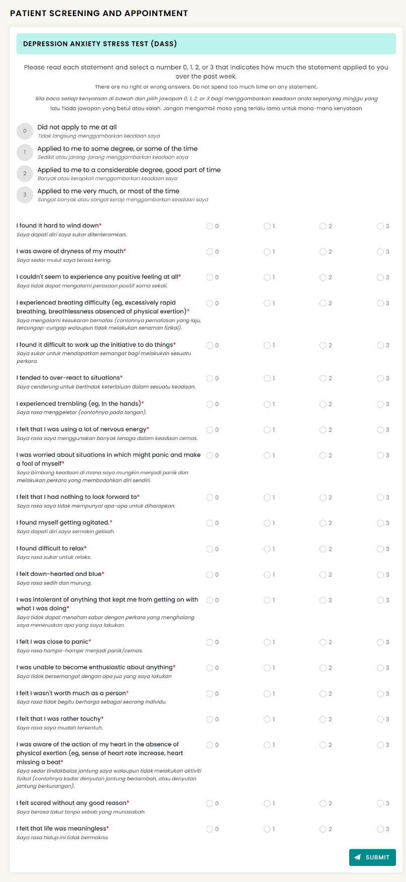

**Appendix A** The DASS-21 Questionnaire (Source: Self-Test – Mentari Malaysia Official Portal, 2024.)

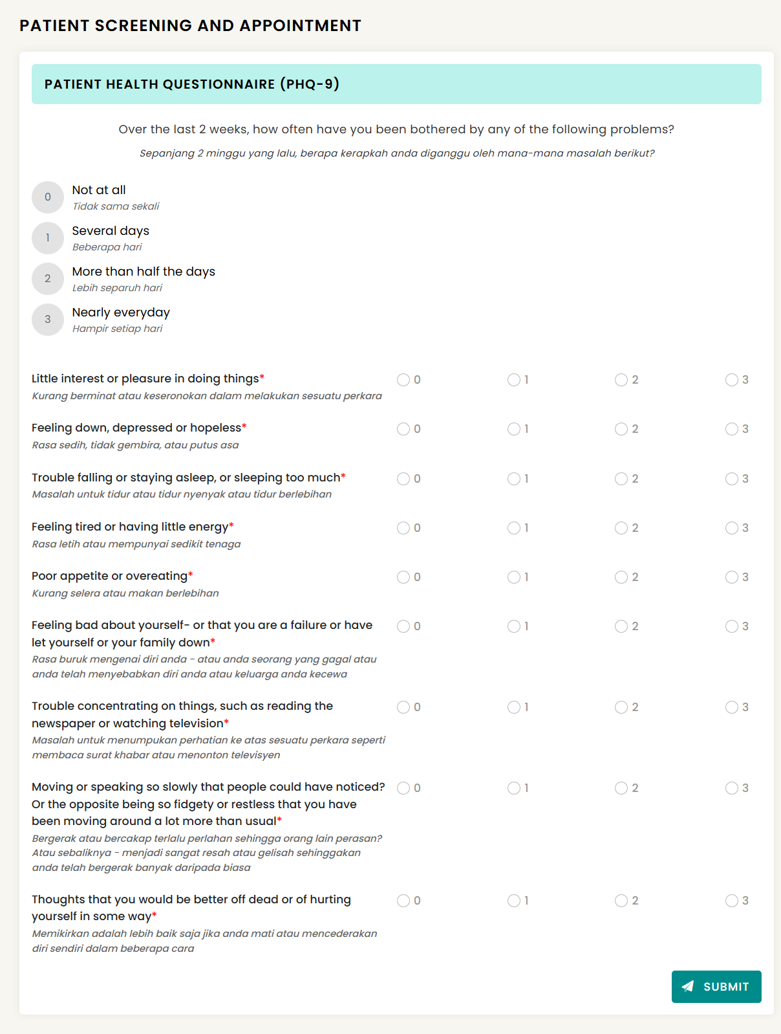

**Appendix B** The PHQ-9 Questionnaire (Source: Self-Test – Mentari Malaysia Official Portal, 2024.)